Tour ID: 221658  
Tour Name: 7 day Guided tour | Hidden Powers & Northern Lights - New Years Version

Tour destinations: ['Reykjavik', 'Seljaland', 'Skogafoss', 'Reynisfjara', 'Kirkjubaejarklaustur', 'Jokulsarlon', 'Skaftafell', 'Hveragerdi', 'Blue Lagoon', 'Gullfoss', 'Geysir', 'Laugarvatn']

Tour destinations images:

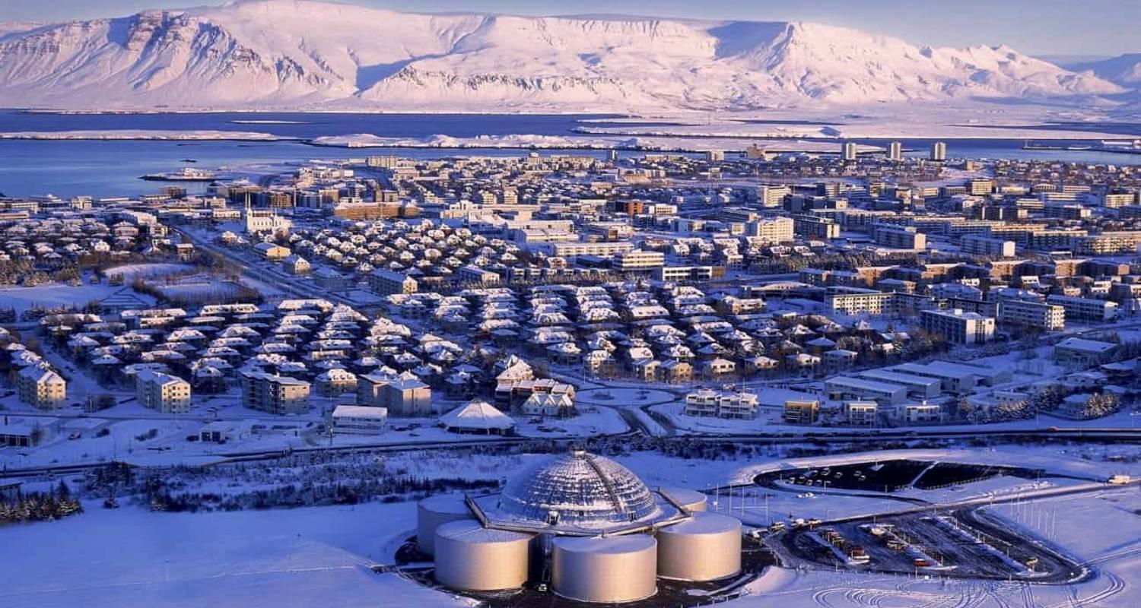

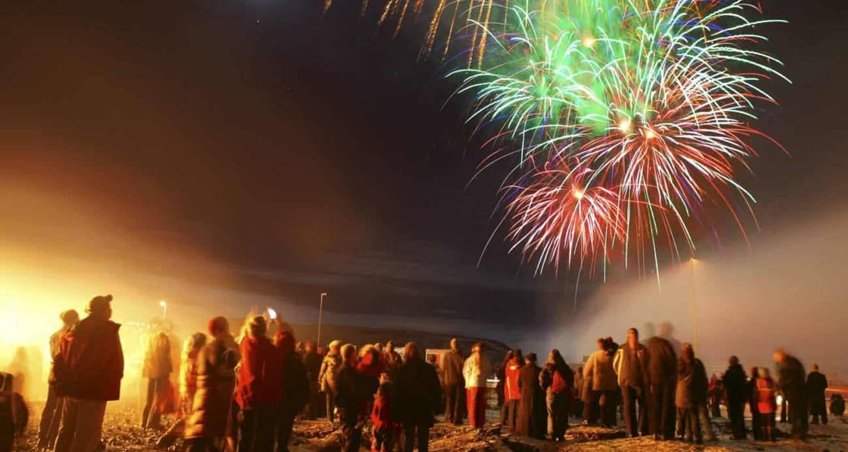

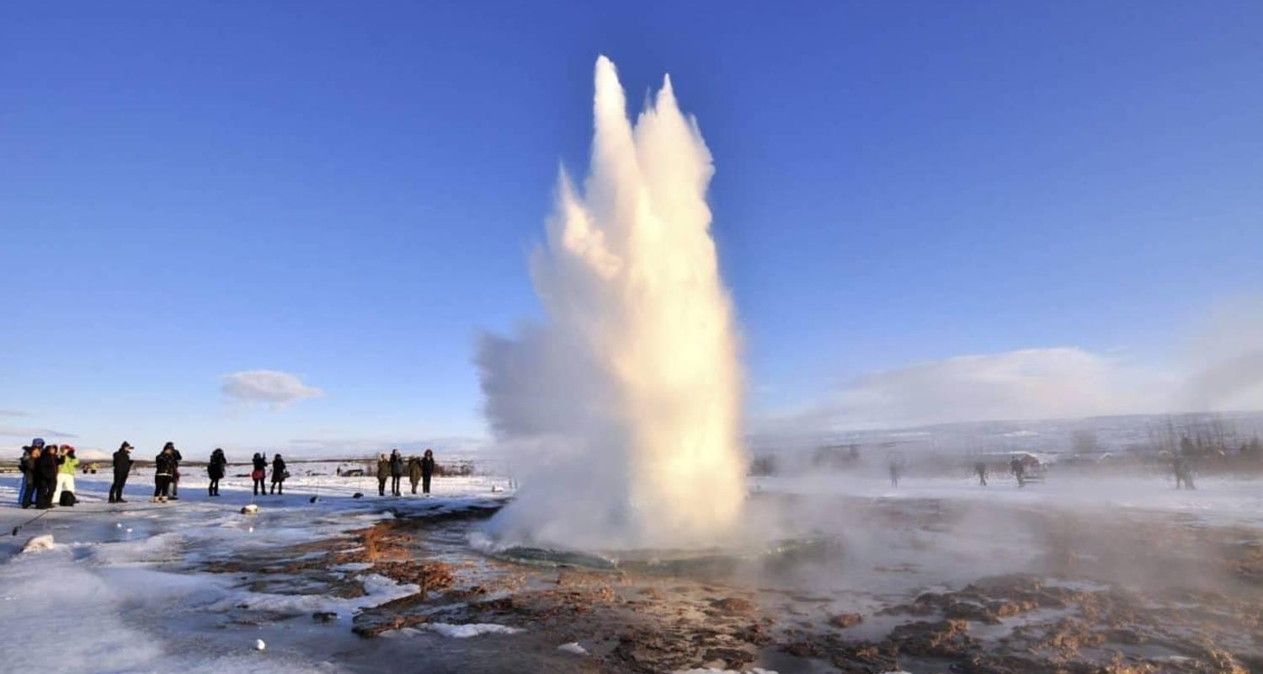

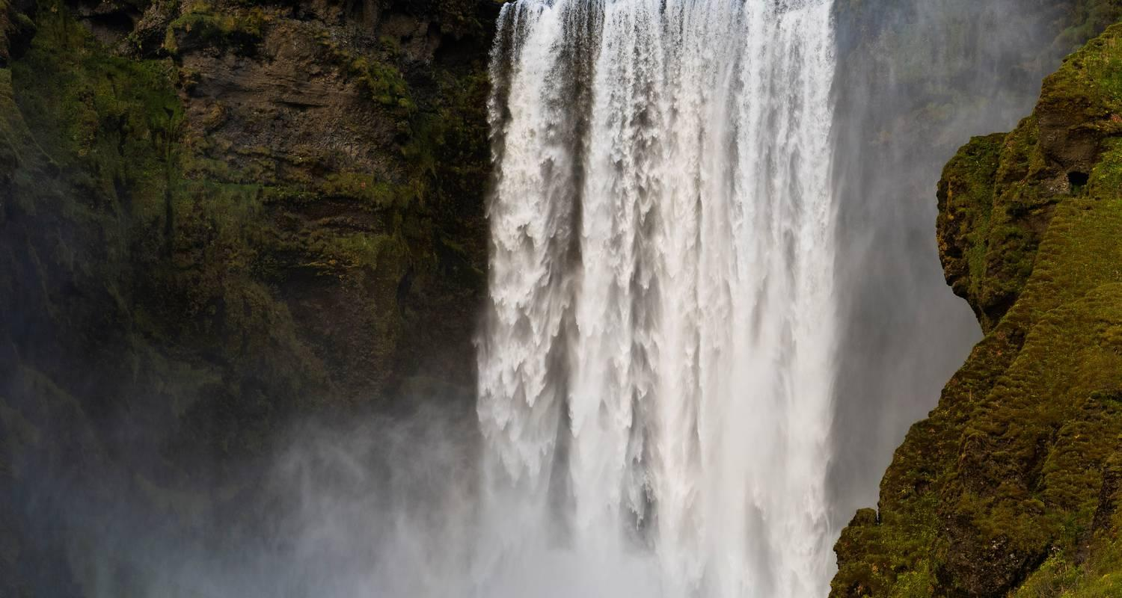

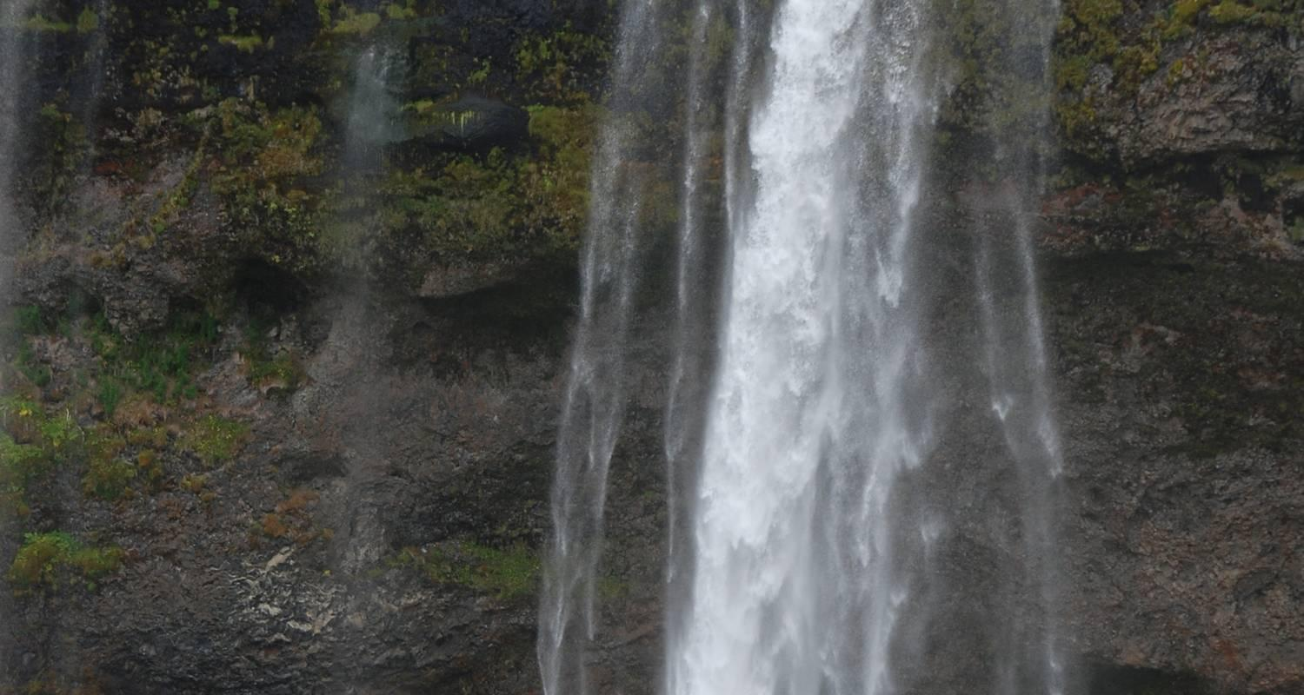

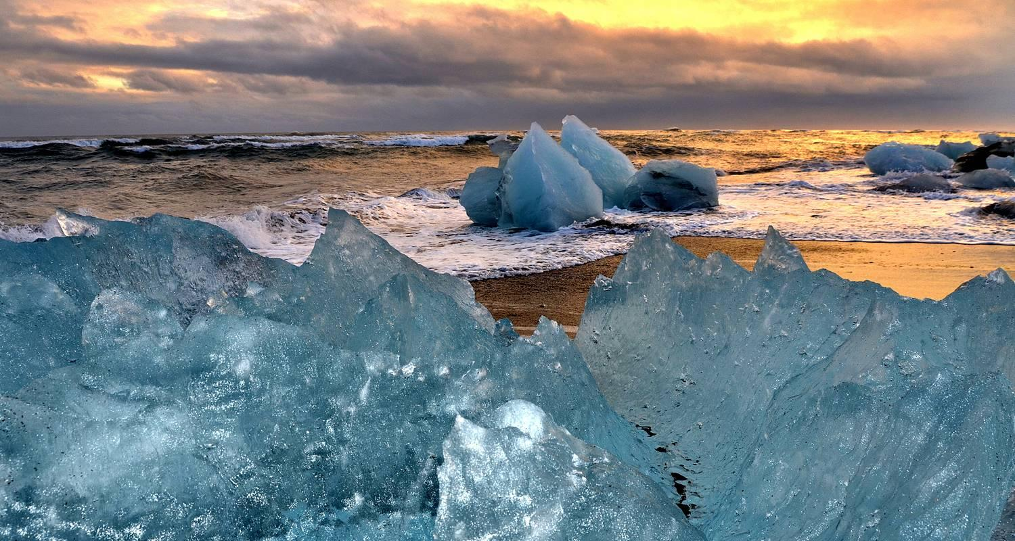

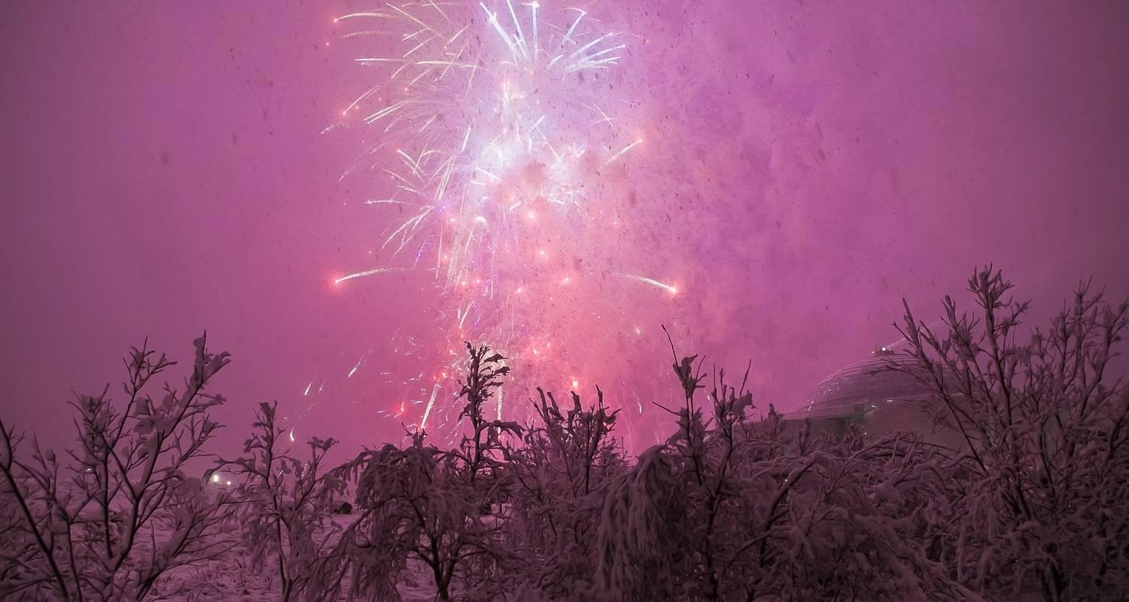

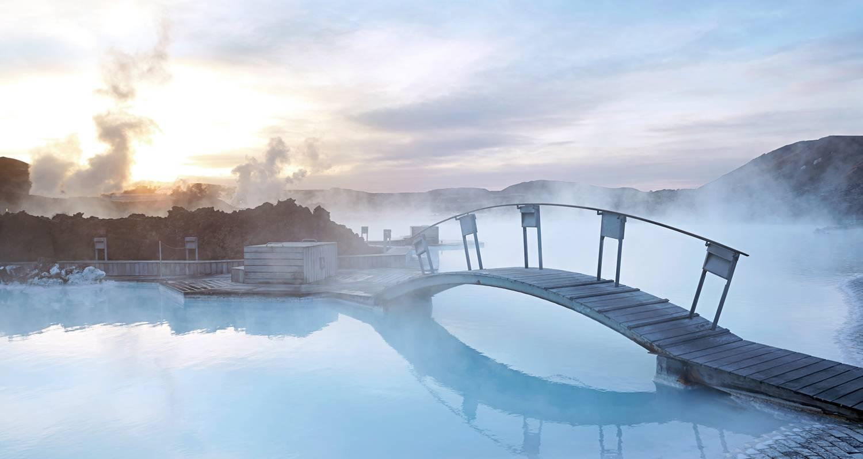

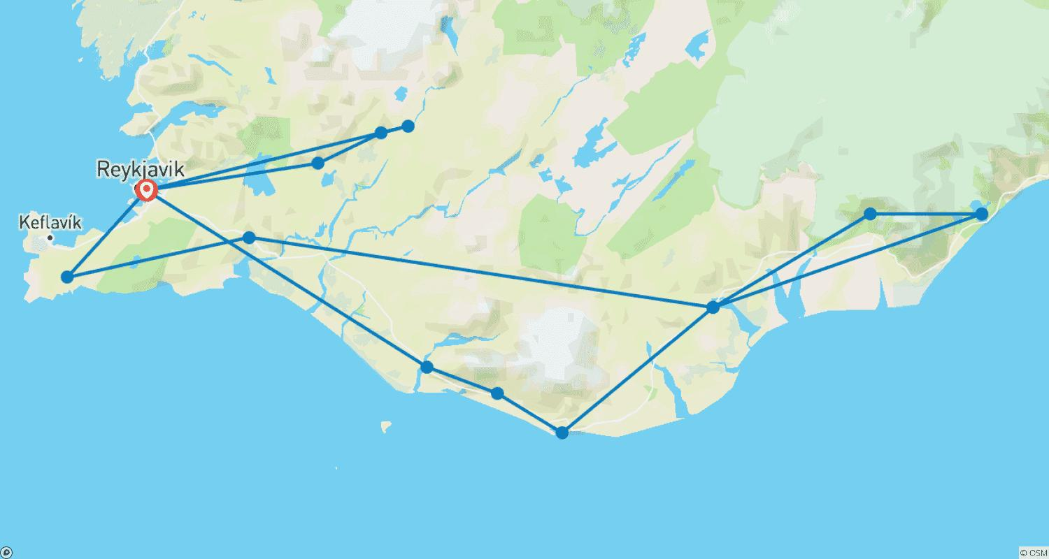

Tour ID: 221704  
Tour Name: 6 day Guided tour | Hidden Powers & Northern Lights - Special Christmas Departure

Tour destinations: ['Reykjavik', 'Thingvellir National Park', 'Geysir', 'Gullfoss', 'Laugarvatn', 'Hella', 'Seljaland', 'Skogafoss', 'Reynisfjara', 'Kirkjubaejarklaustur', 'Jokulsarlon', 'Skaftafell', 'Hveragerdi', 'Blue Lagoon']

Tour destinations images:



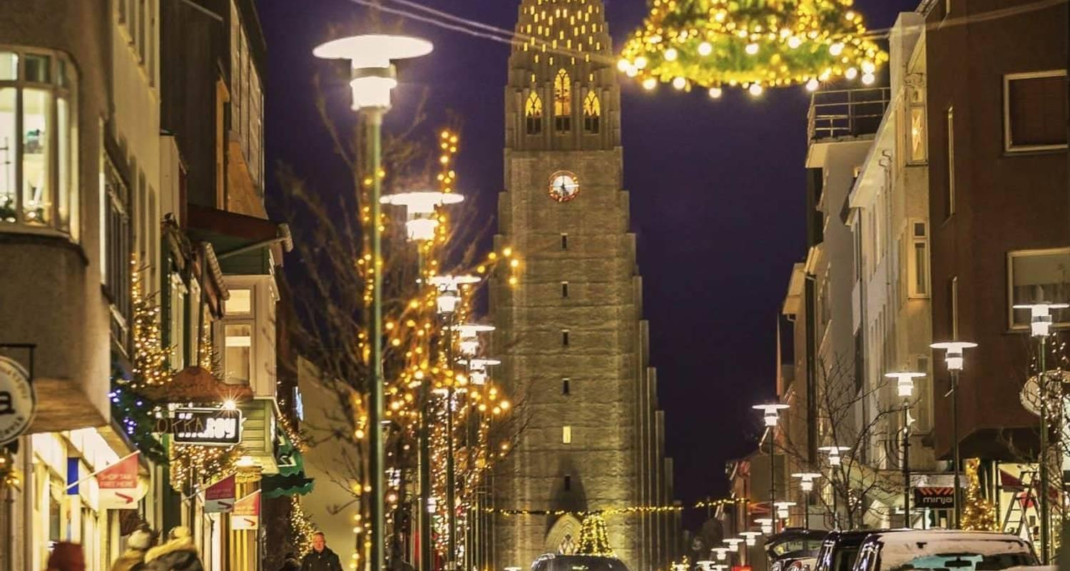

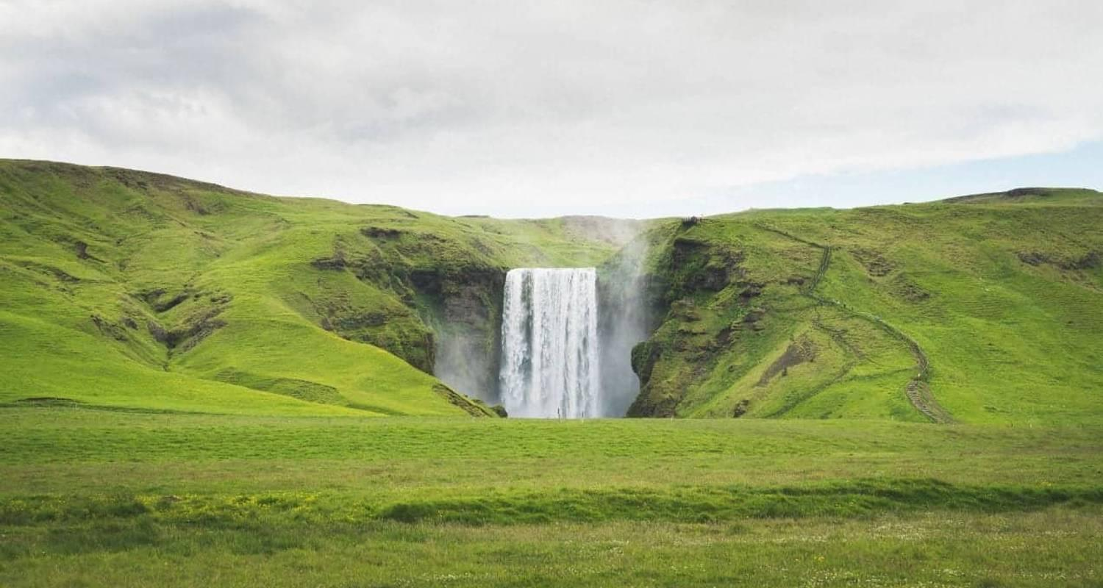





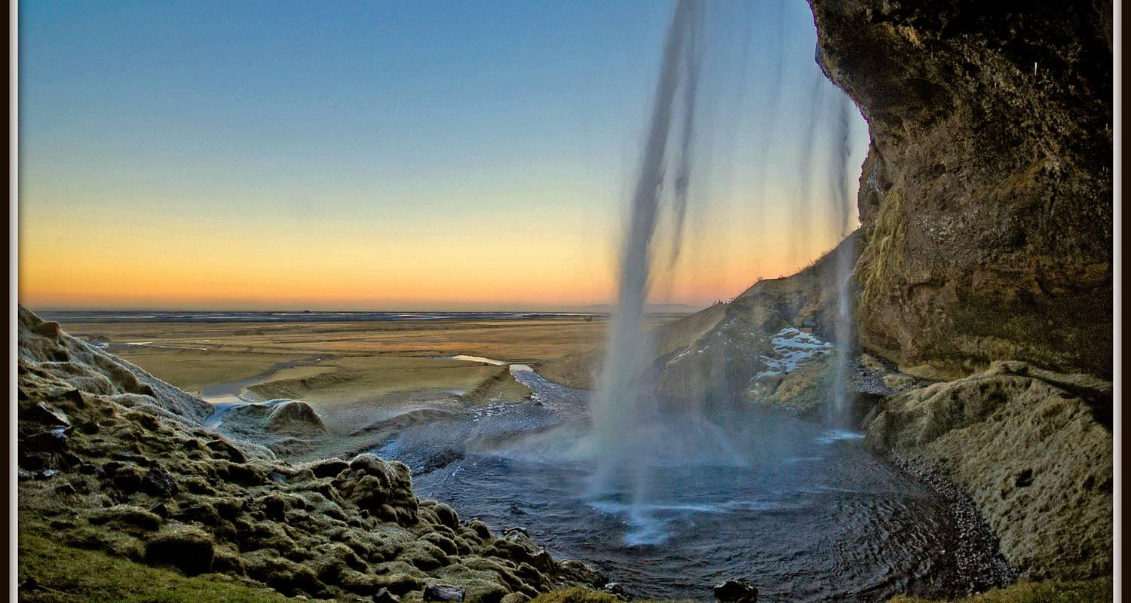

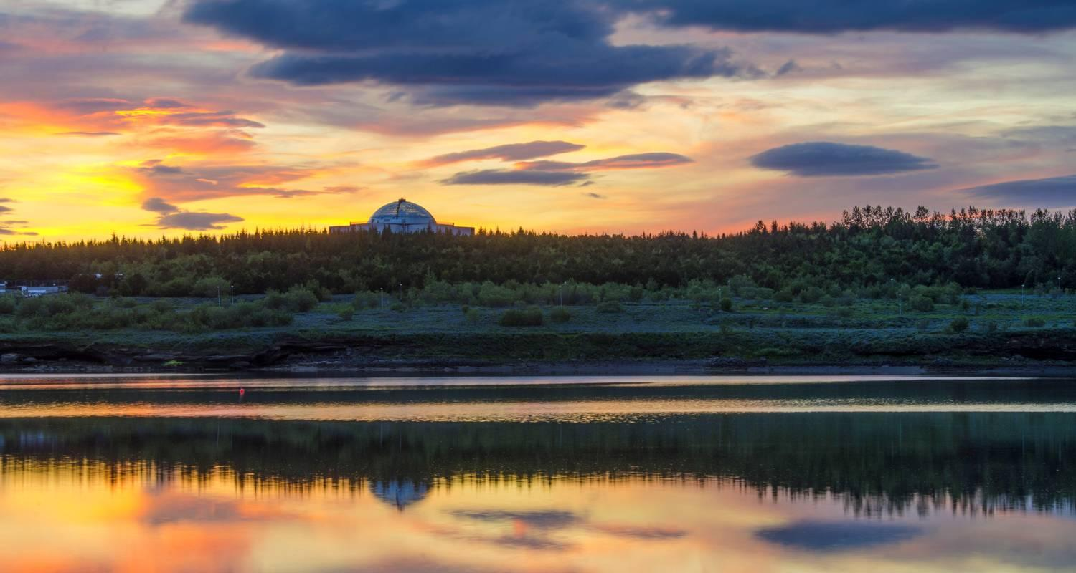

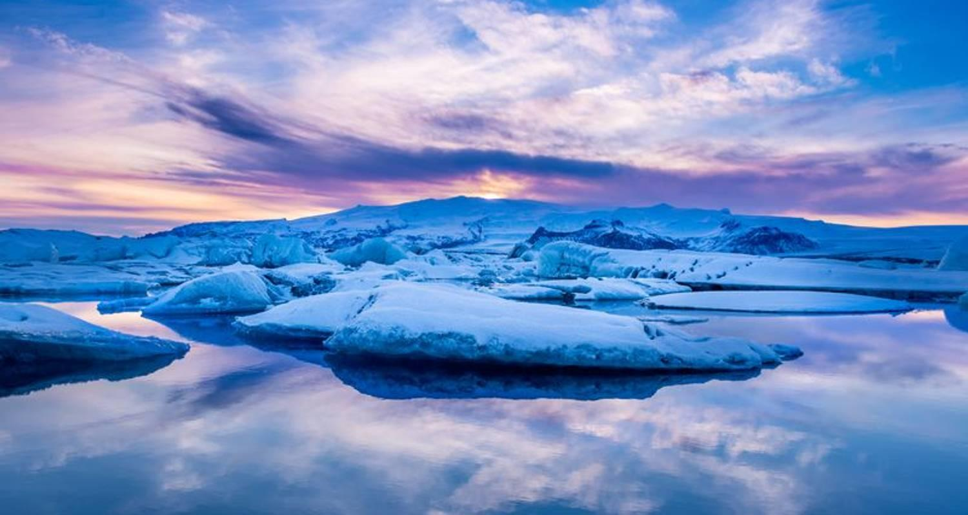

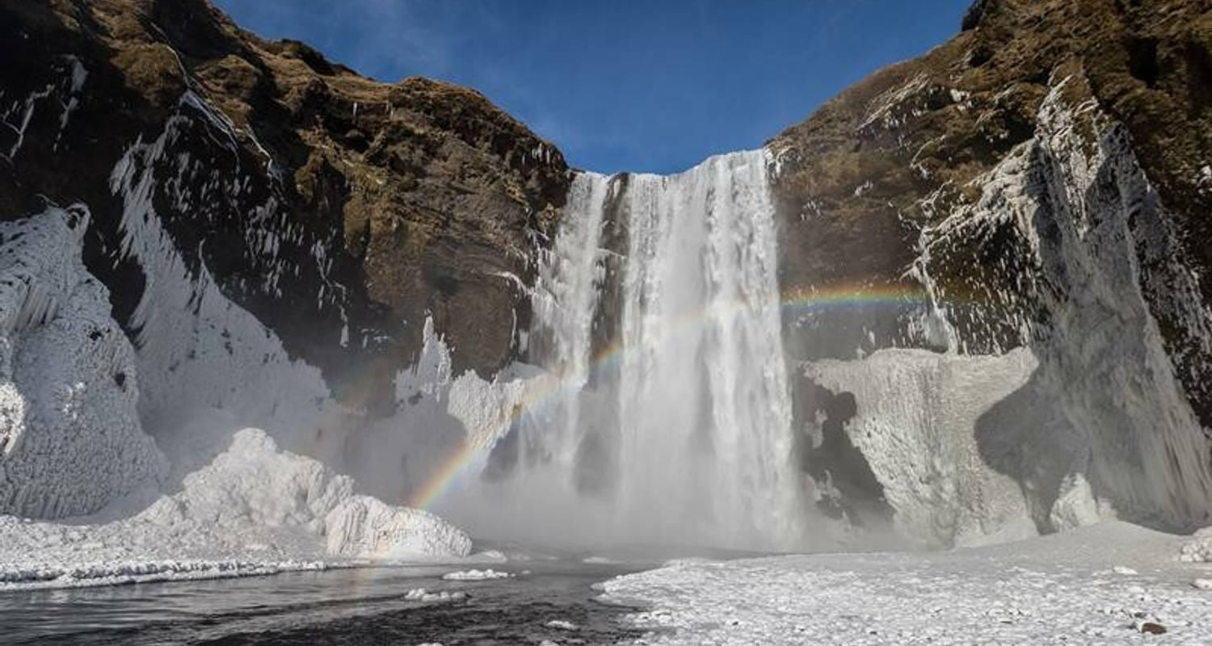

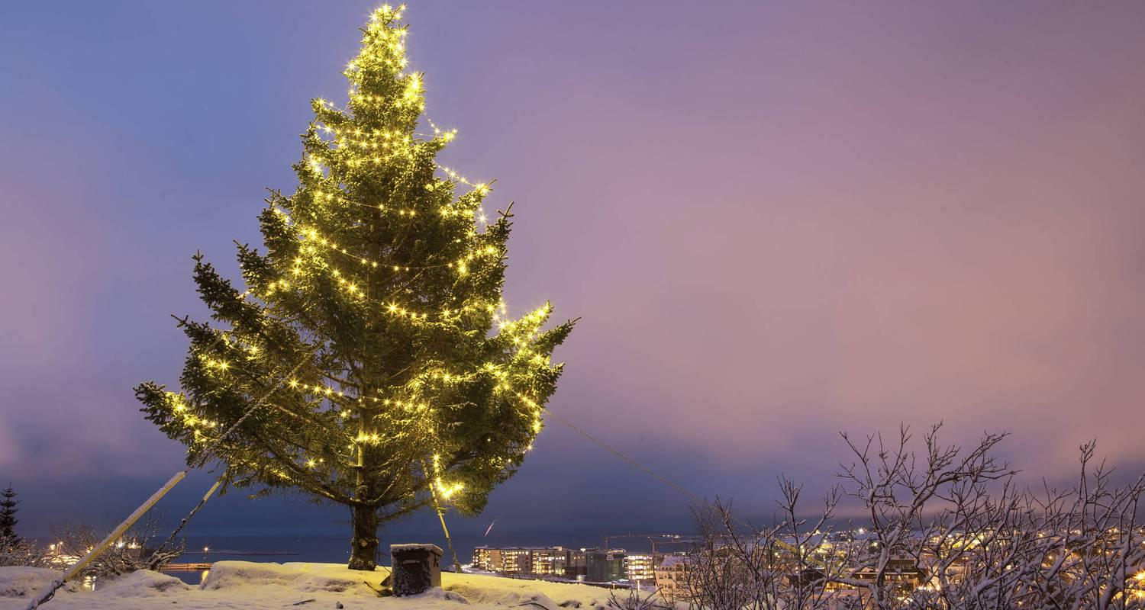

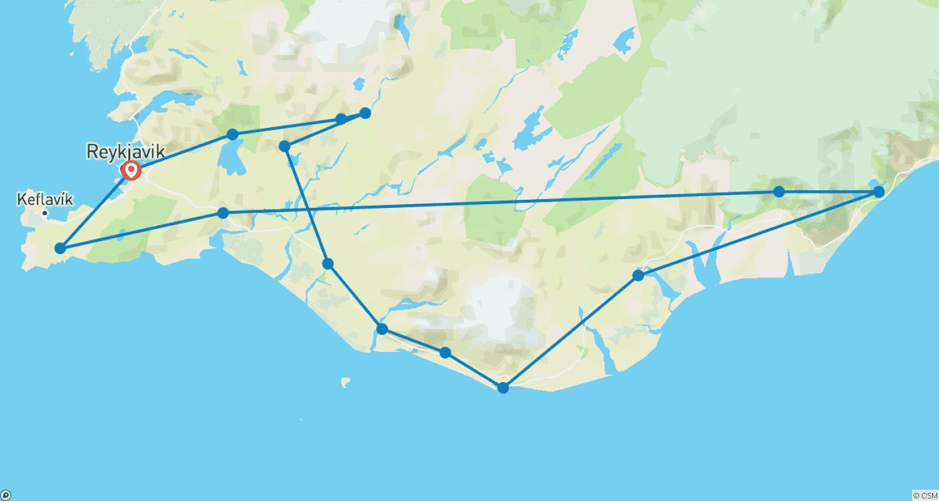

Tour ID: 222462  
Tour Name: Laugavegur Trail Self Guided

Tour destinations: ['Reykjavik', 'Landmannalaugar', 'Hrafntinnusker Mountain', 'Alftavatn', 'Thorsmork Nature Reserve']

Tour destinations images:

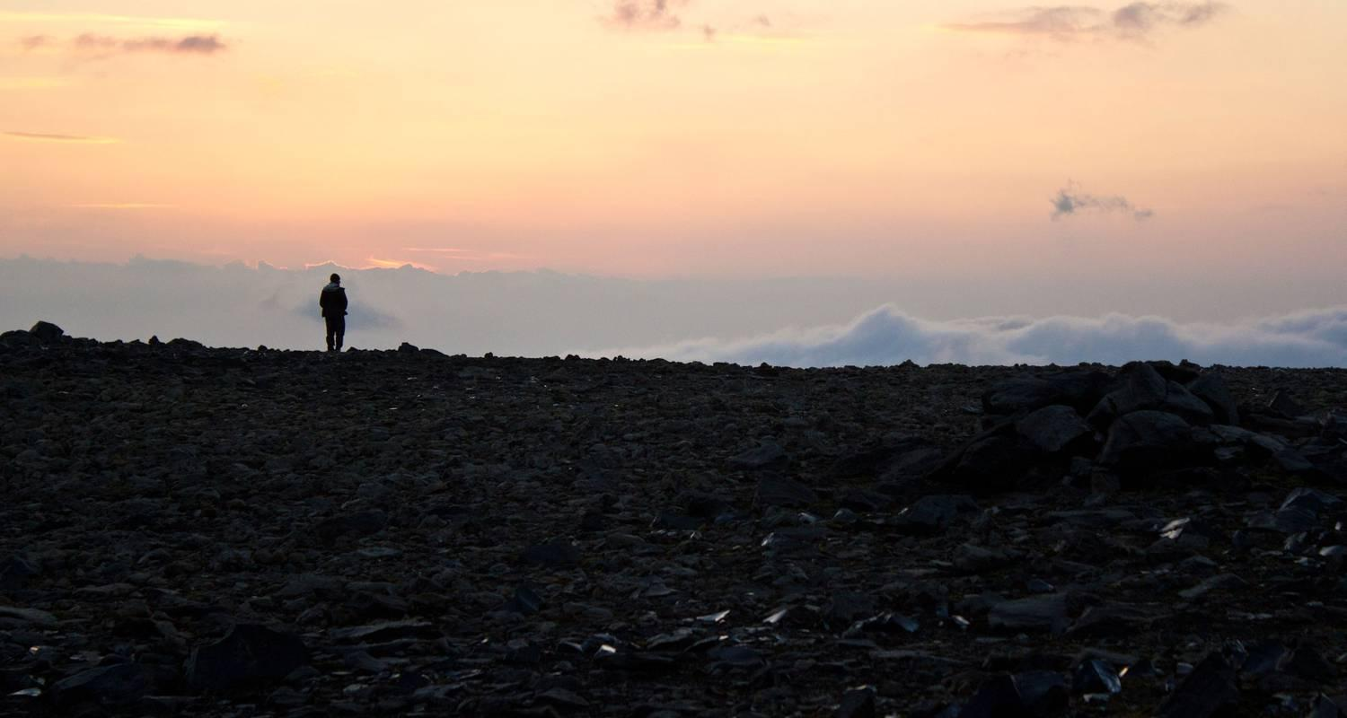

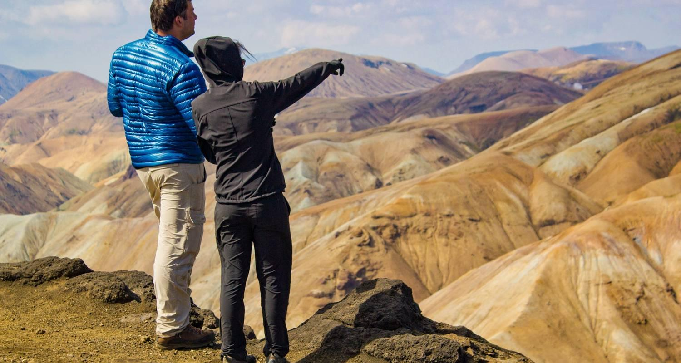

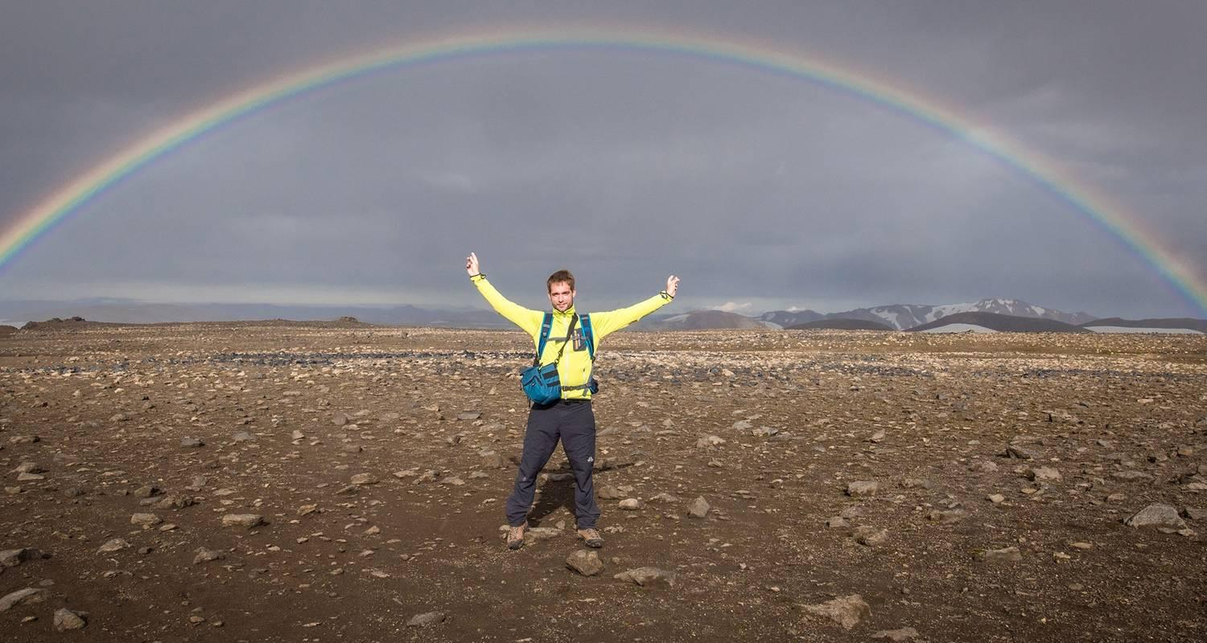

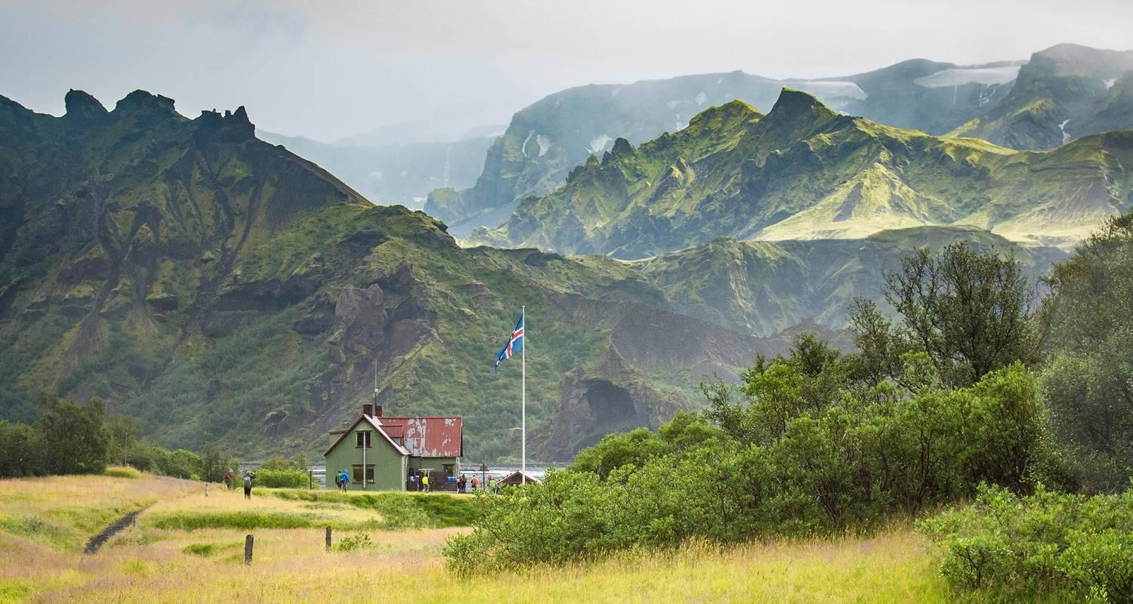

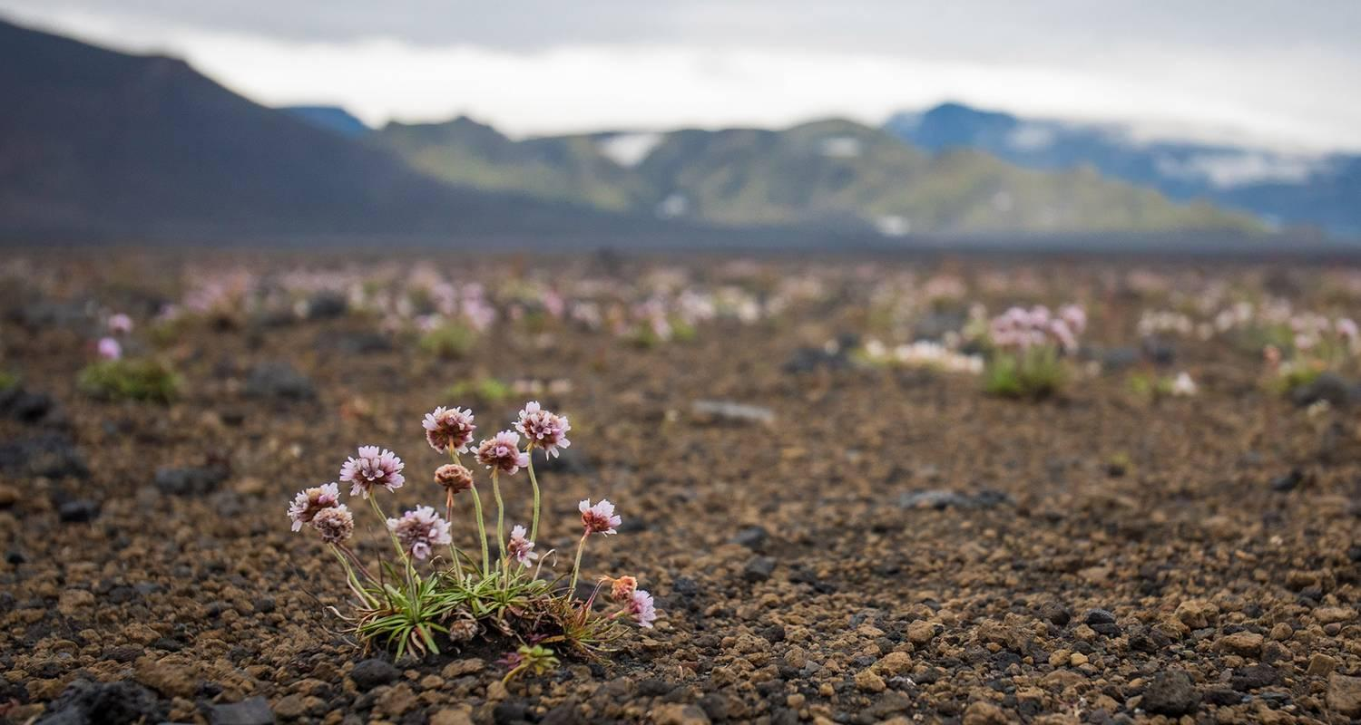

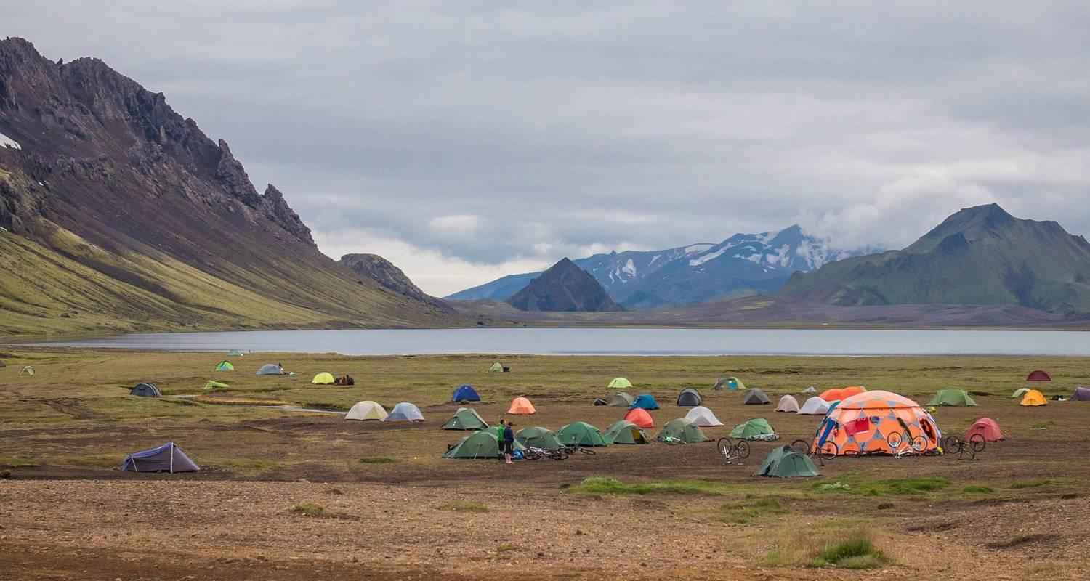

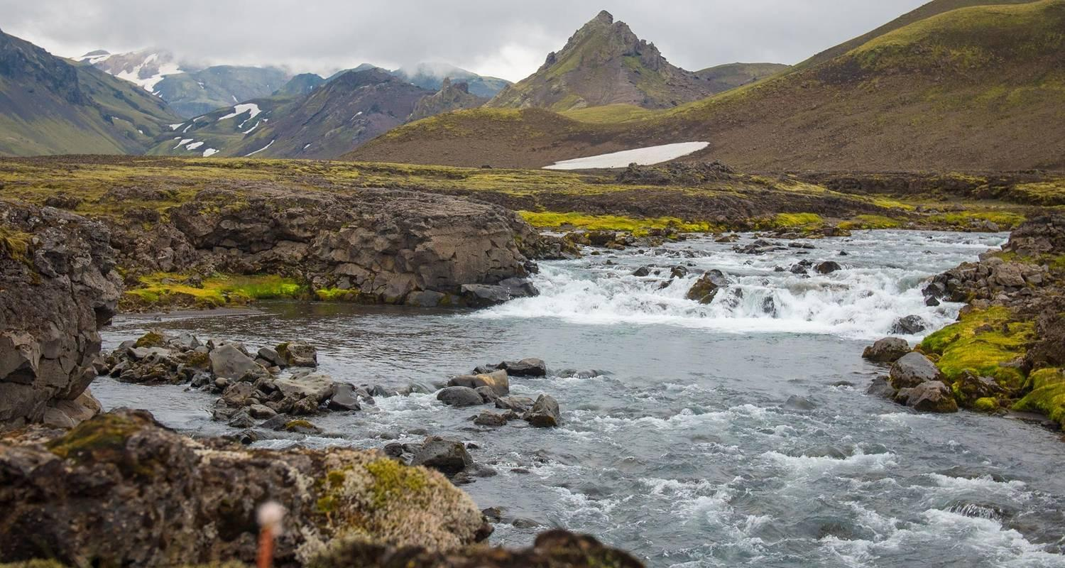

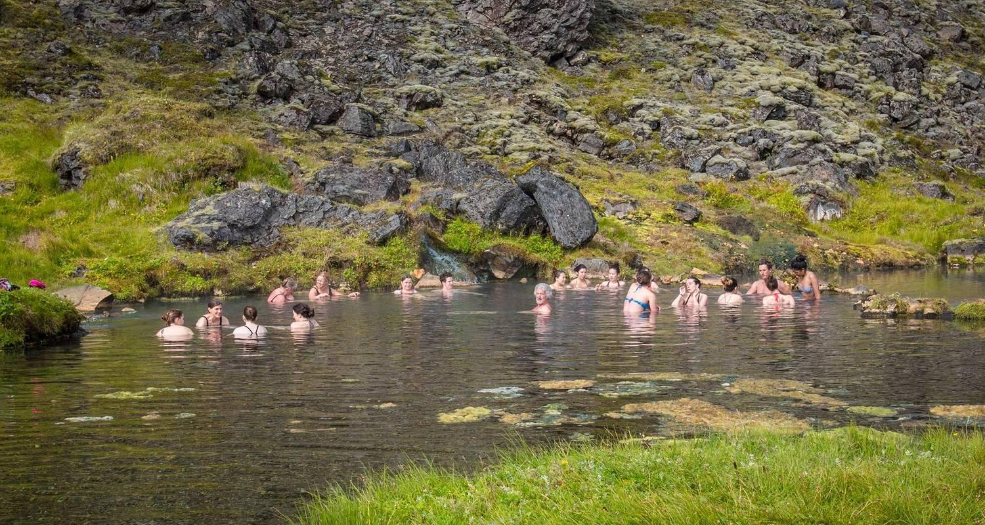

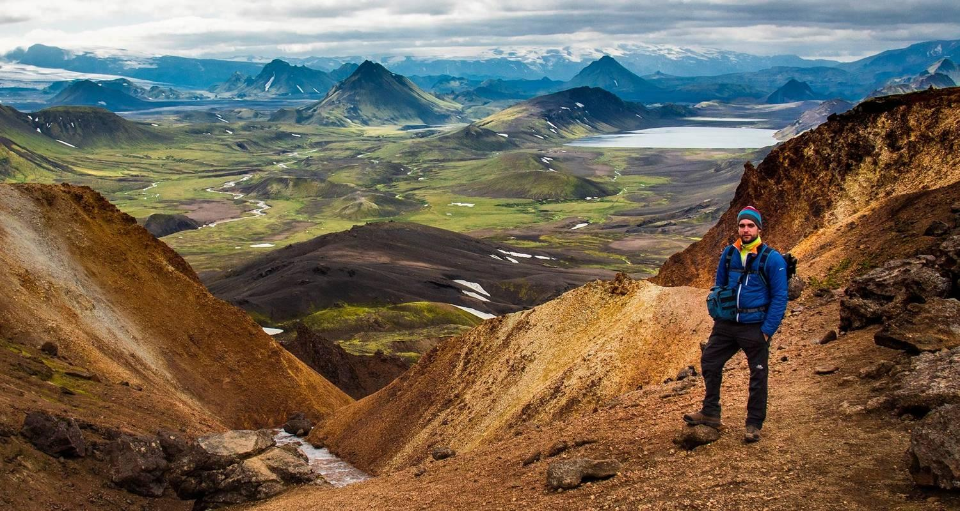

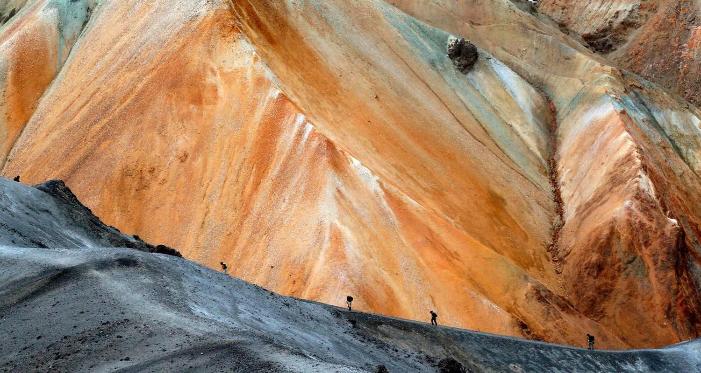

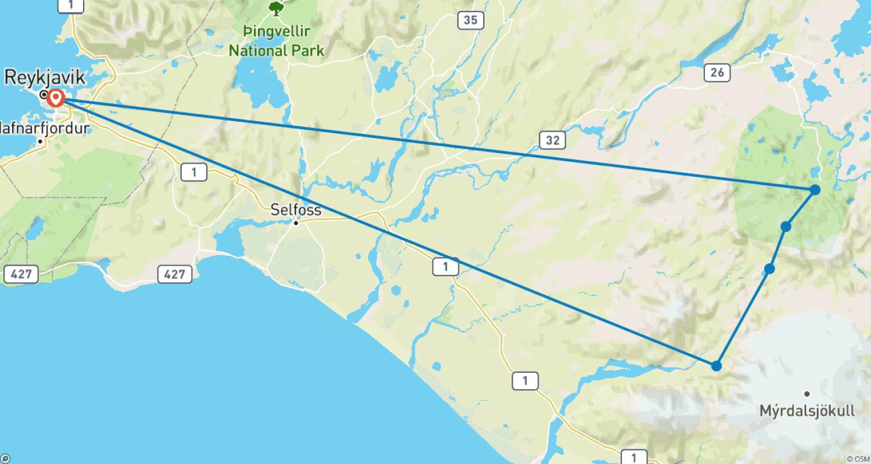

Tour ID: 222608  
Tour Name: In the Wake of Eric the Red 11 days/10 nights

Tour destinations: ['Reykjavik', 'Skjoldungen', 'Nuuk', 'Qeqertarsuaq', 'Ilulissat', 'Sarfannguit', 'Kangerlussuaq']

Tour destinations images:

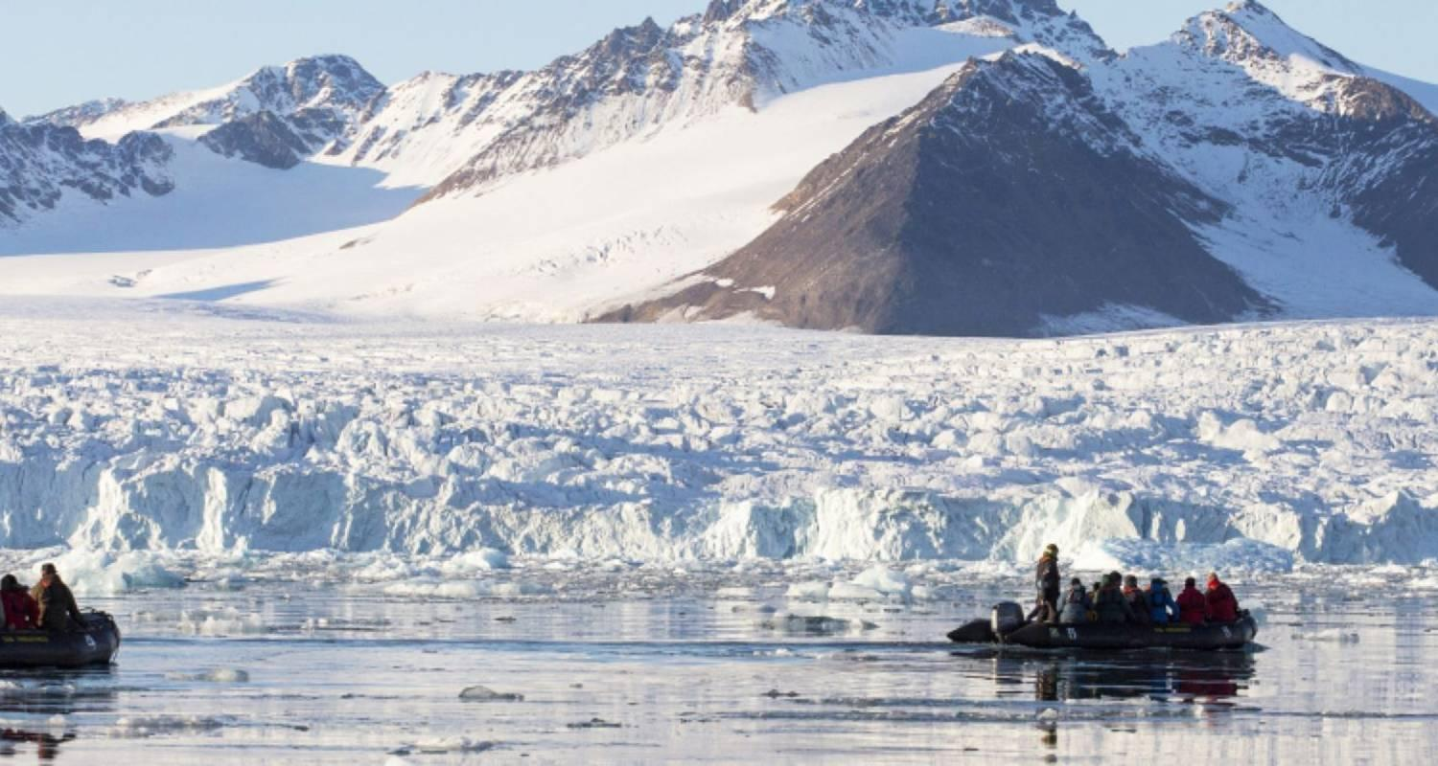

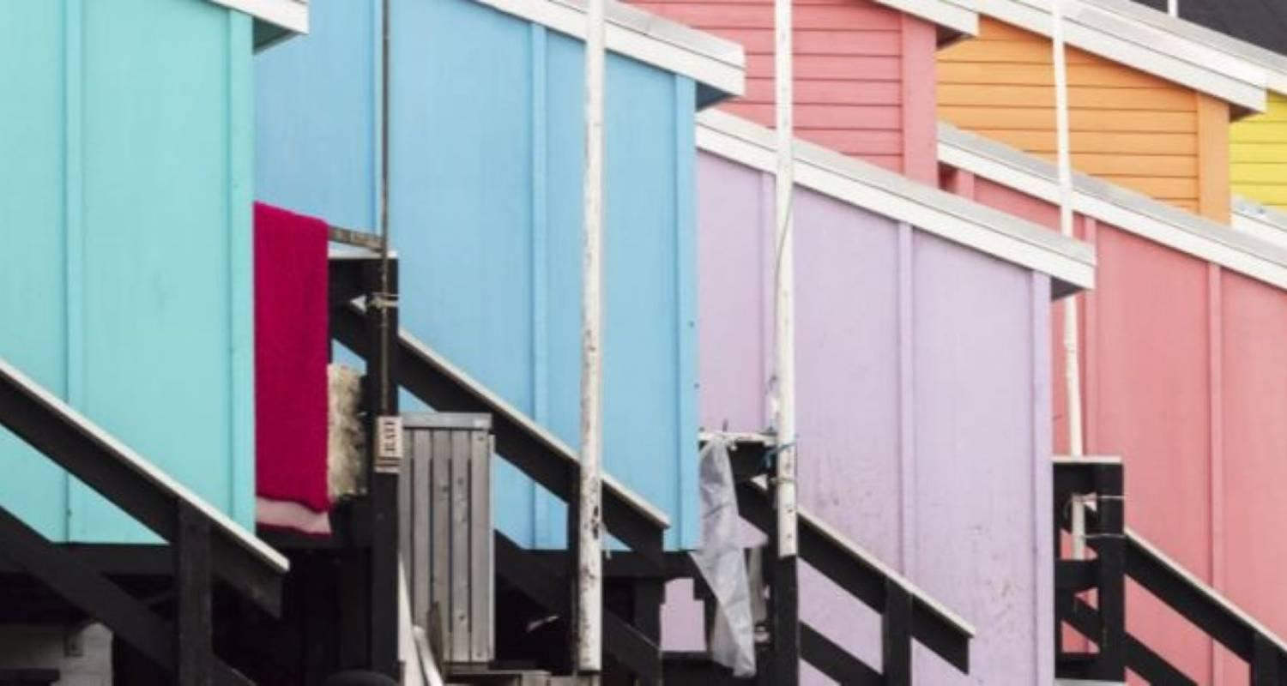

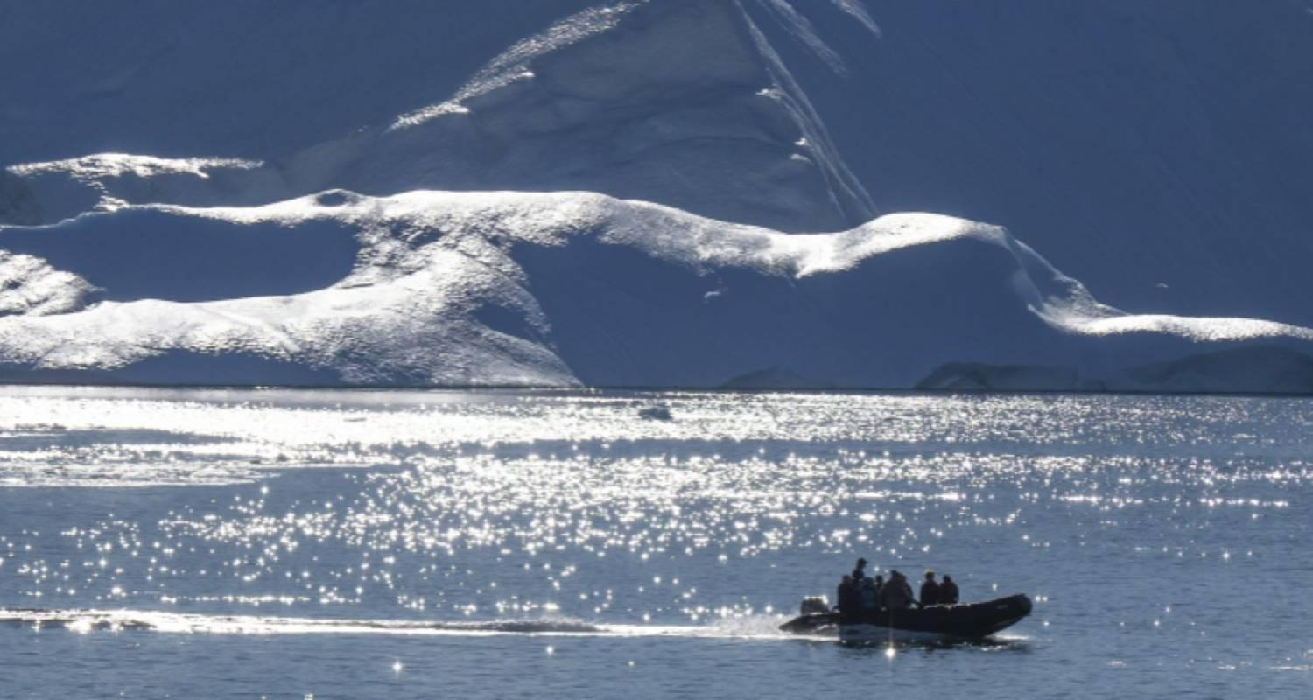

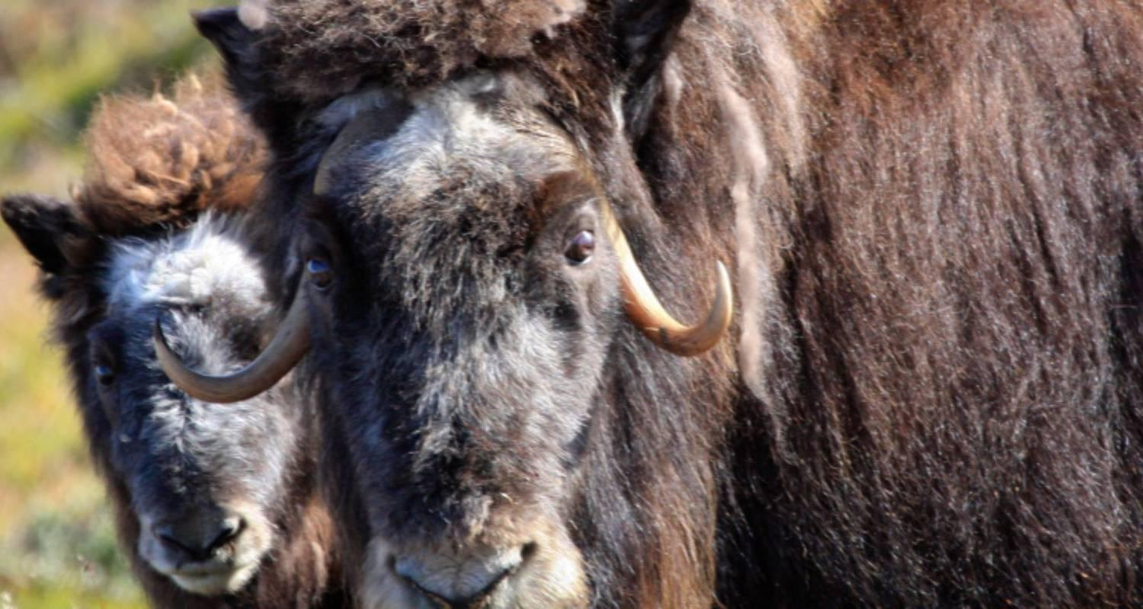

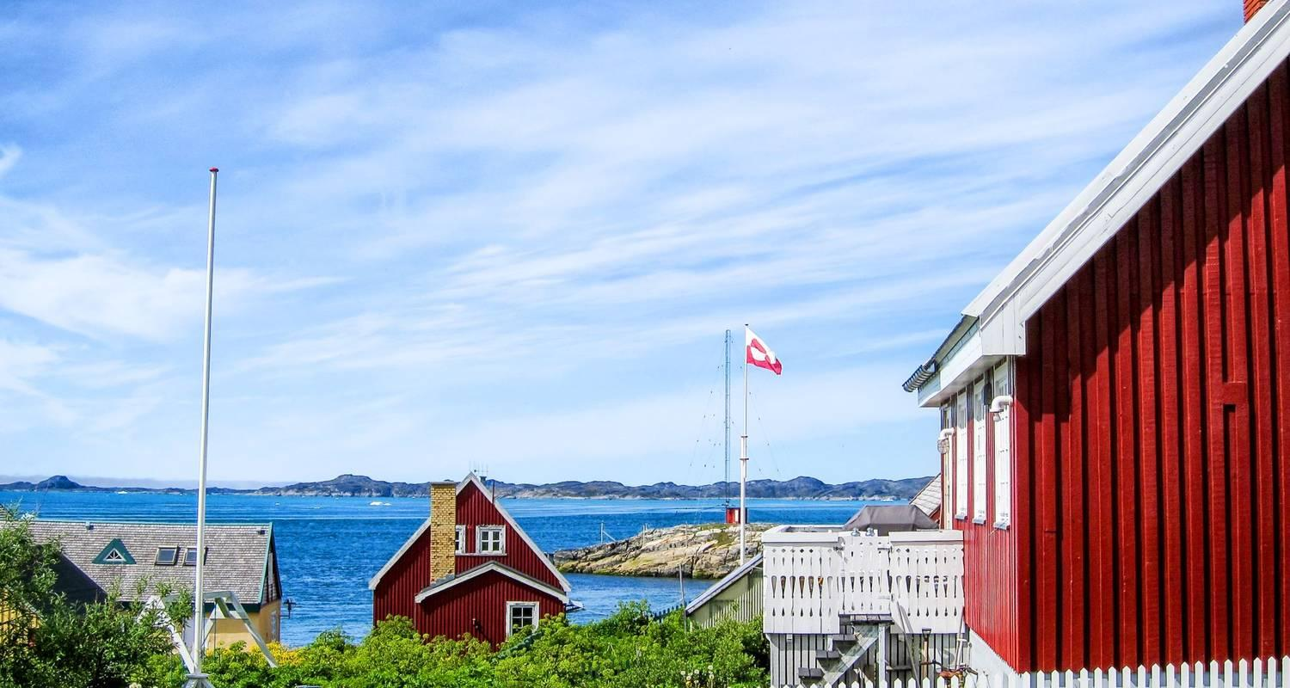

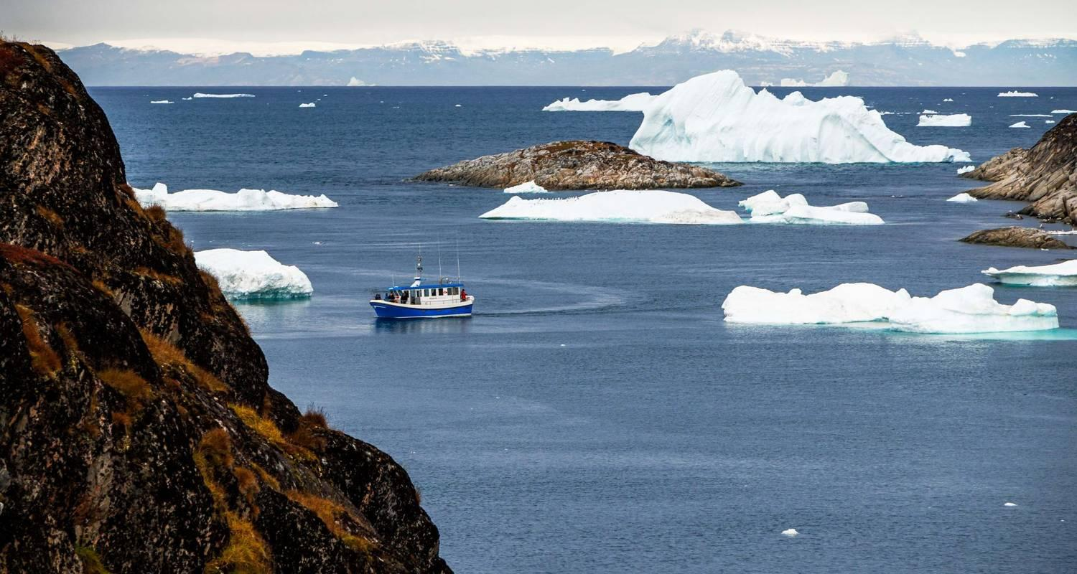

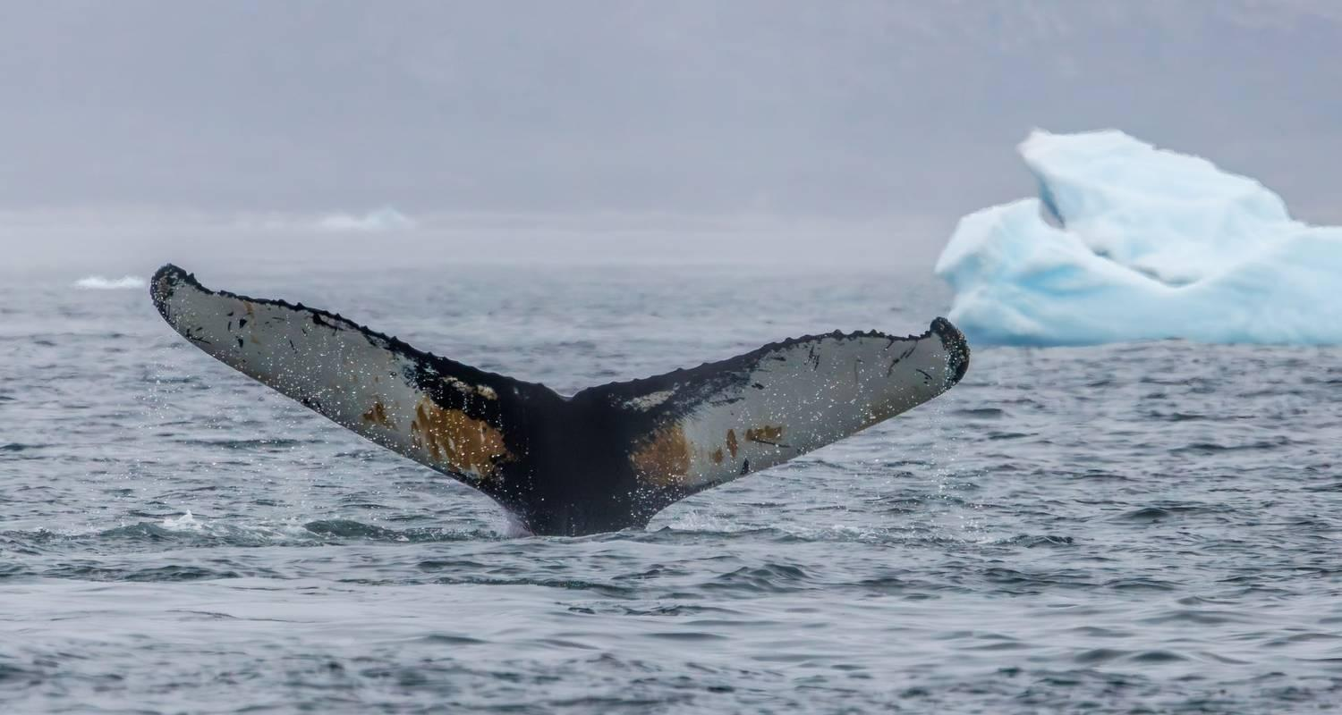

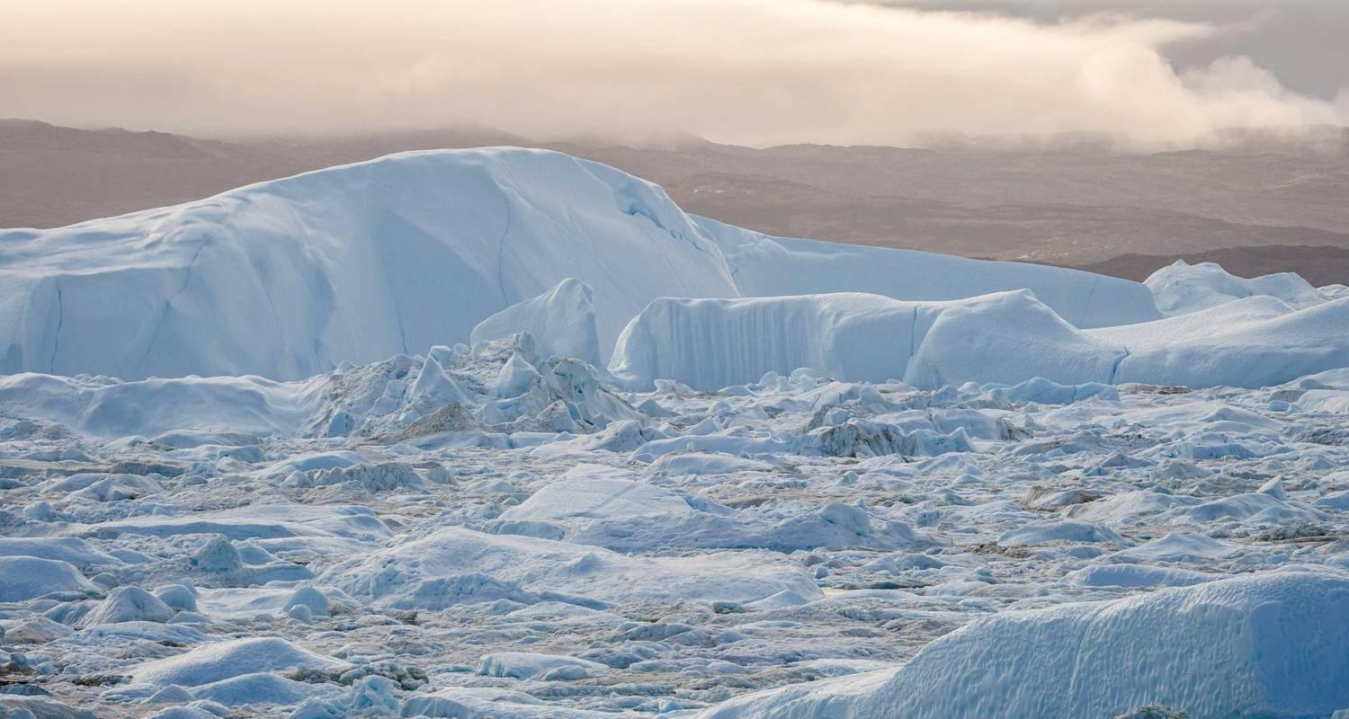

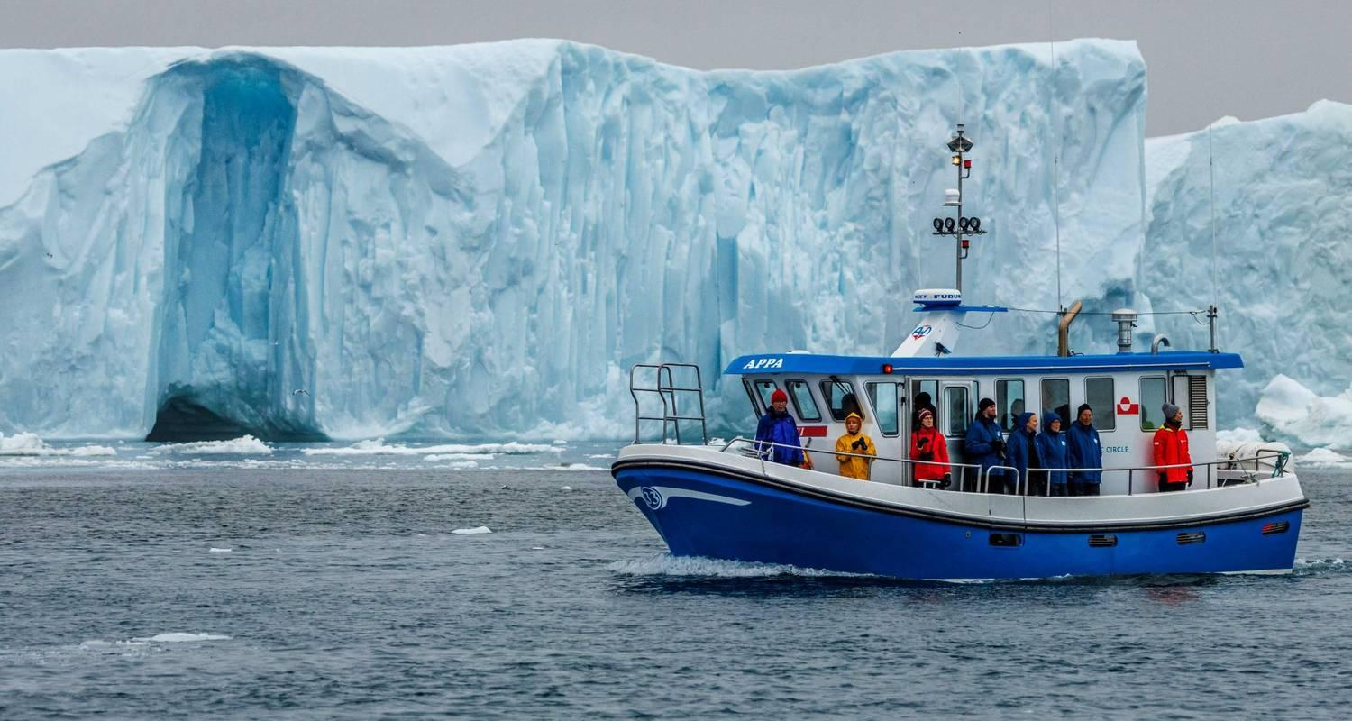

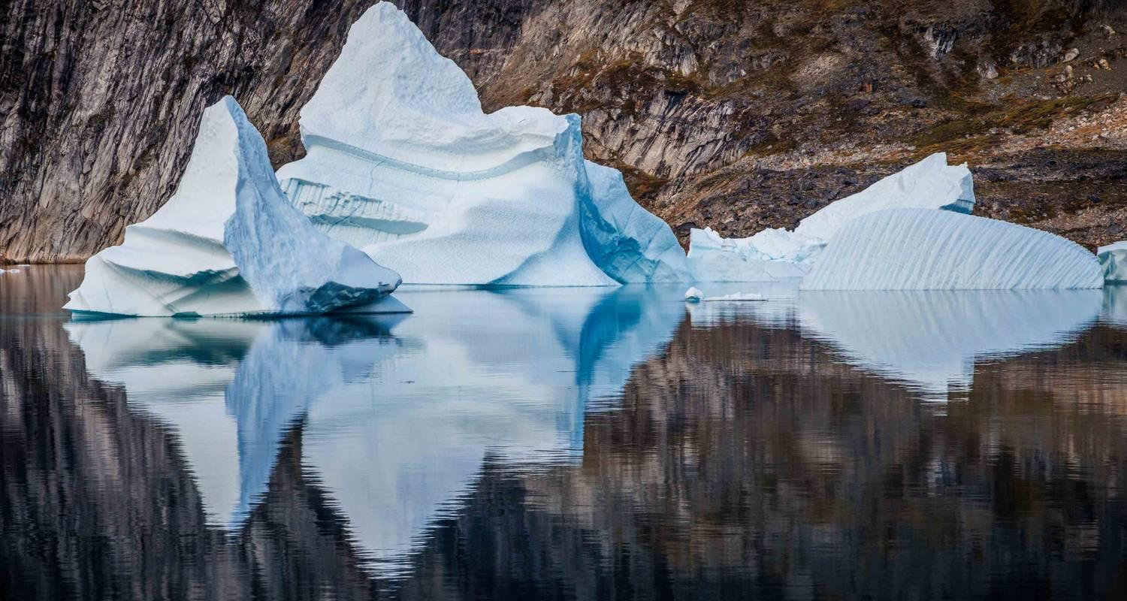

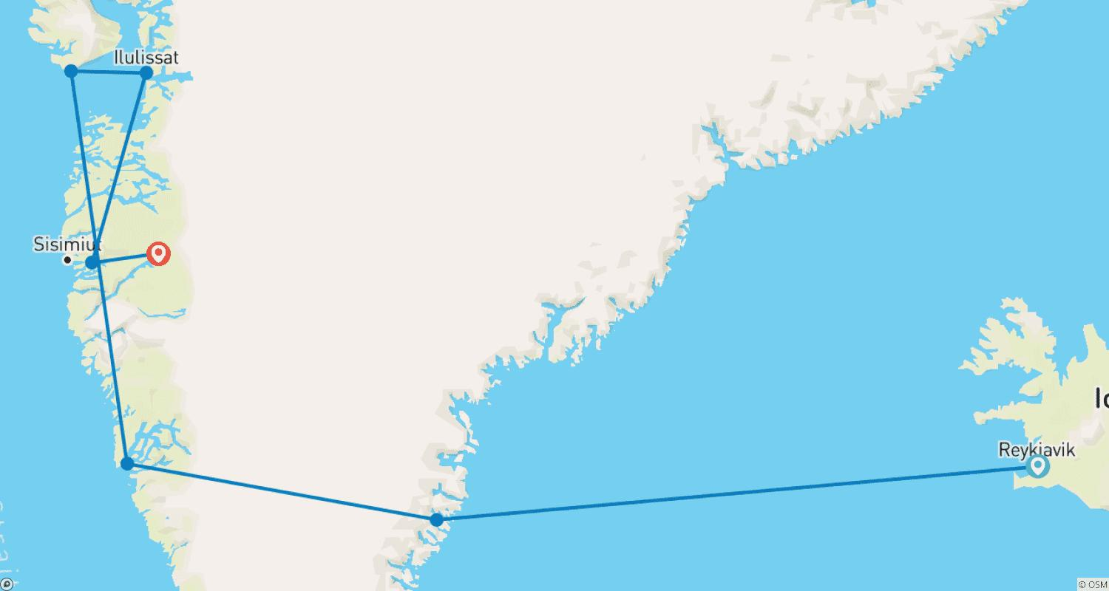

Tour ID: 222696  
Tour Name: Iceland Escape

Tour destinations: ['Reykjavik', 'Geysir', 'Gullfoss', 'Thingvellir National Park']

Tour destinations images:

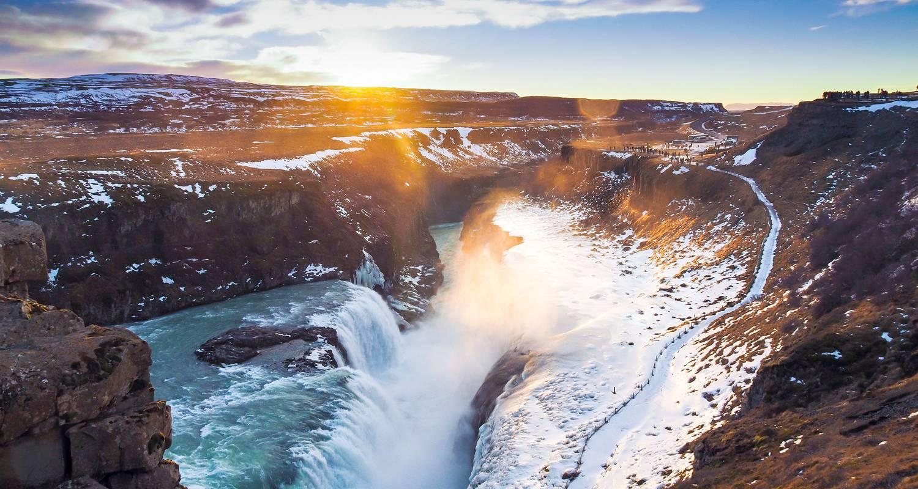

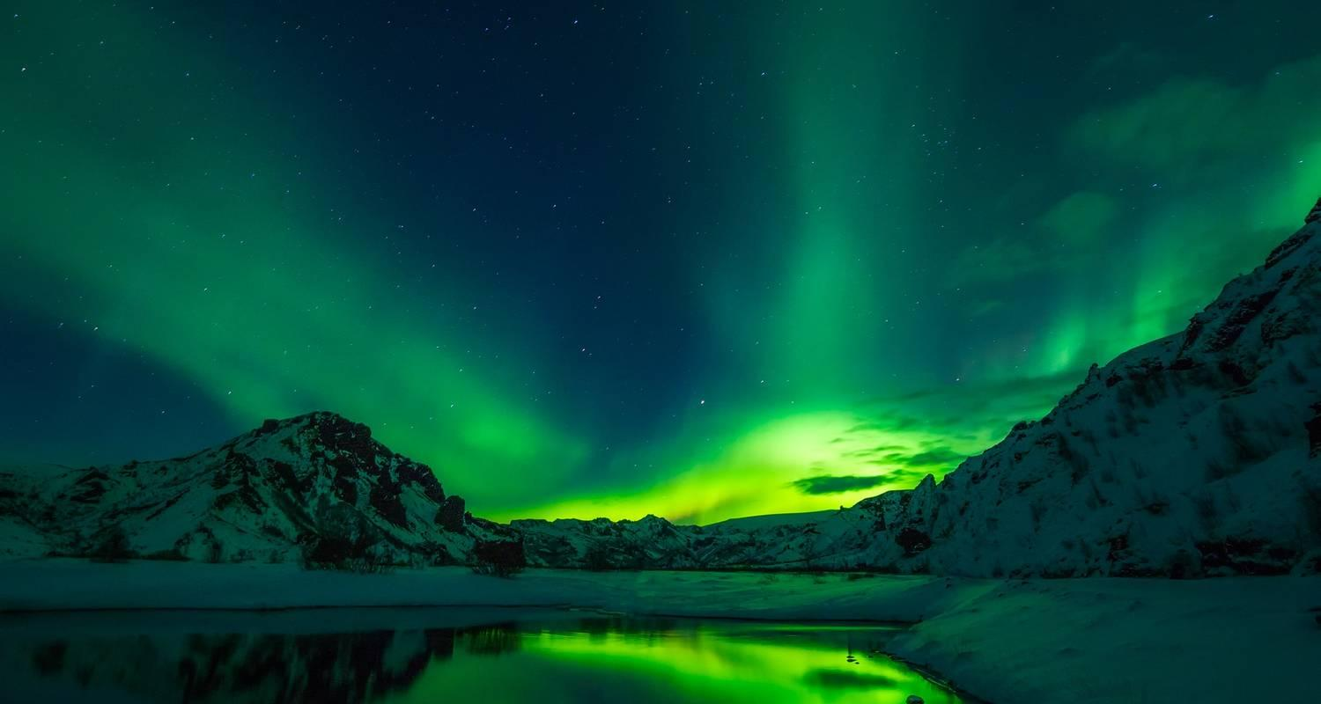

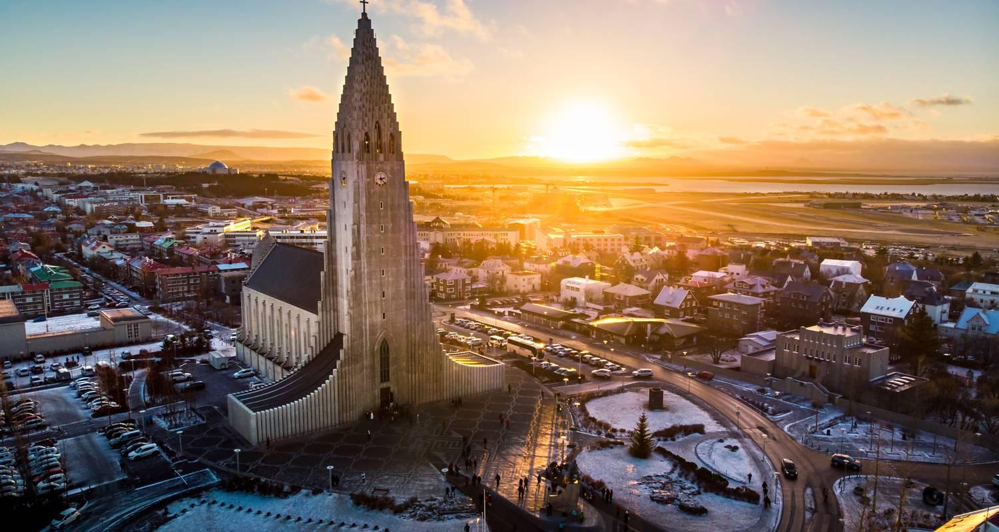

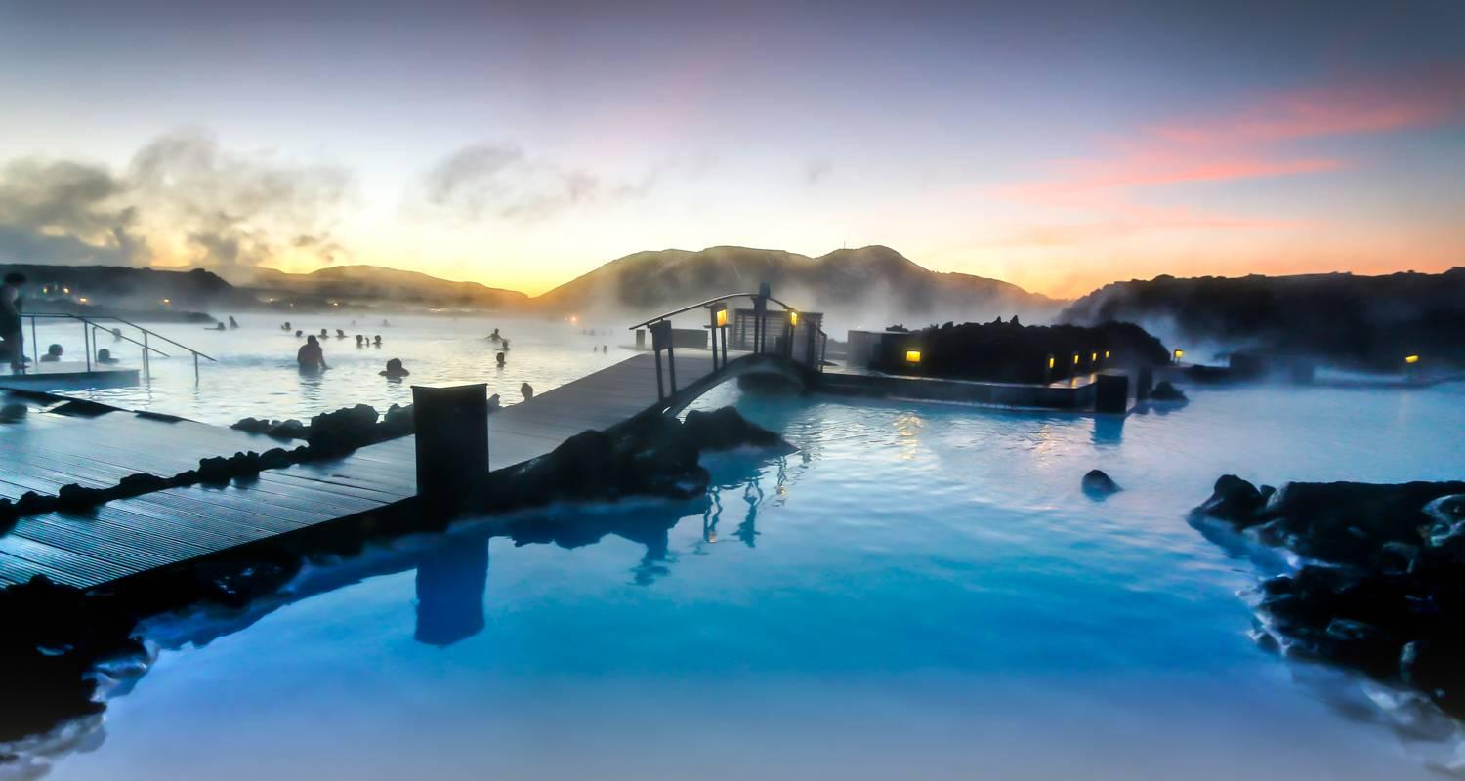

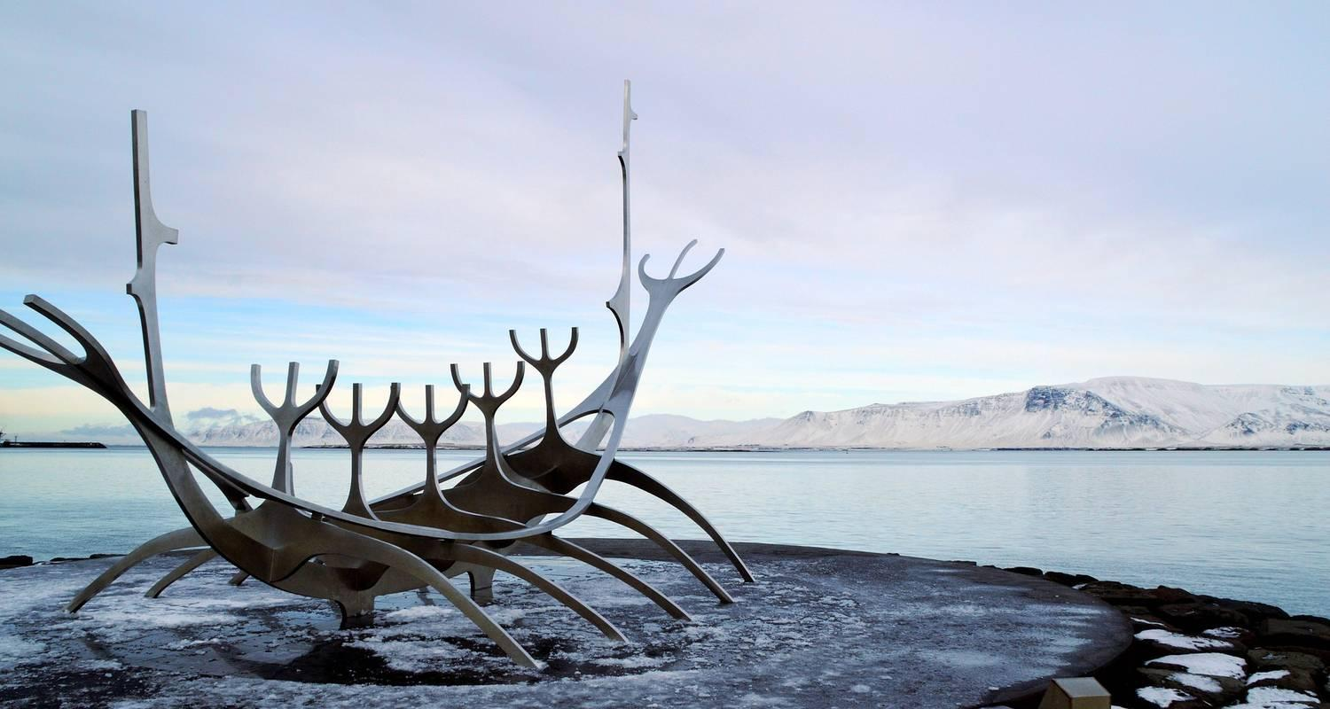

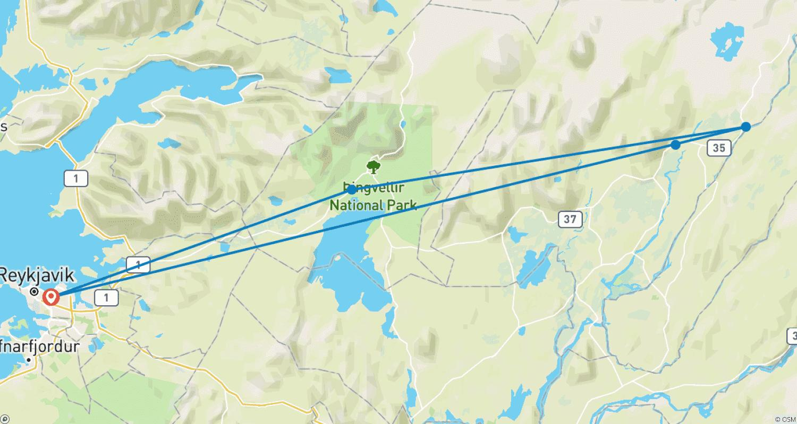

Tour ID: 223448  
Tour Name: 2 Day South Coast Tour - Private Tour

Tour destinations: ['Reykjavik', 'Skogafoss', 'Solheimajokull', 'Reynisdrangar Cliffs', 'Reynisfjara', 'Vik', 'Skaftafell', 'Jokulsarlon']

Tour destinations images:

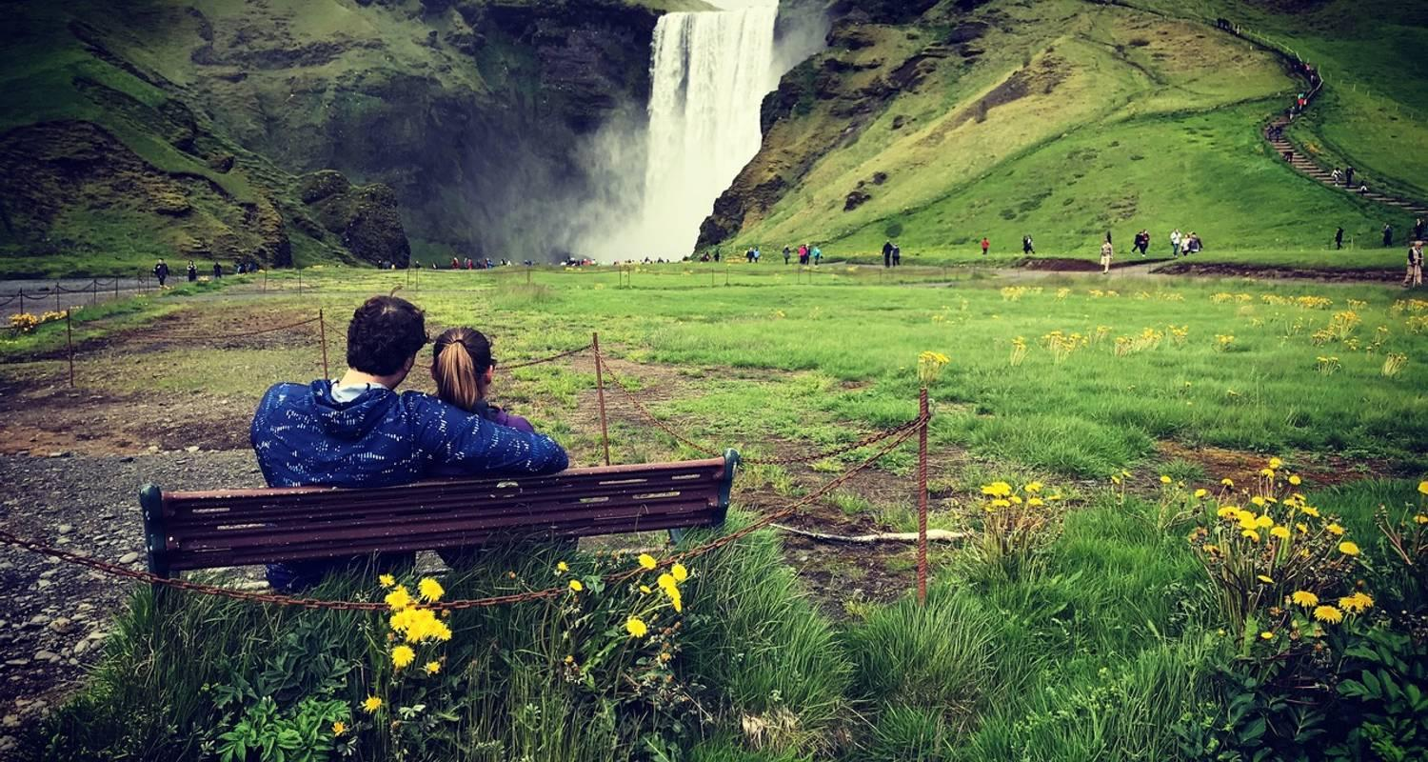

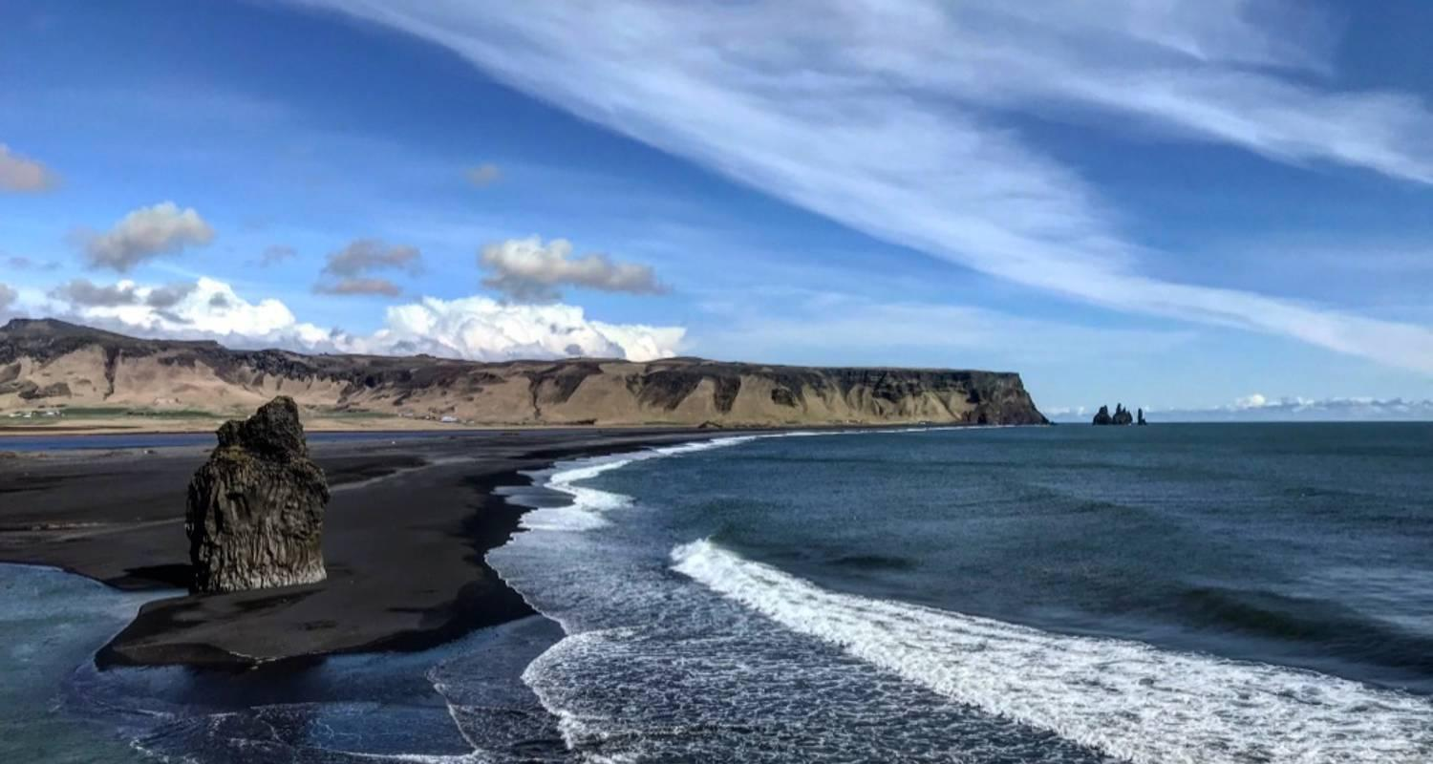

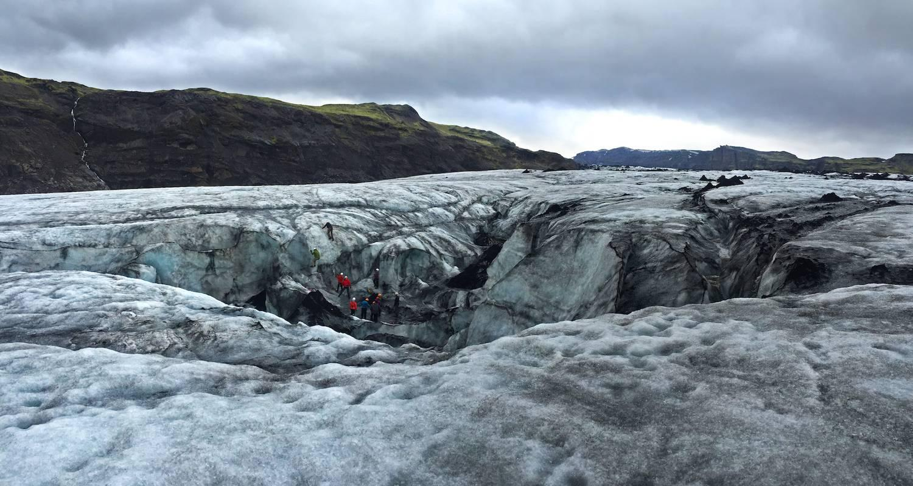

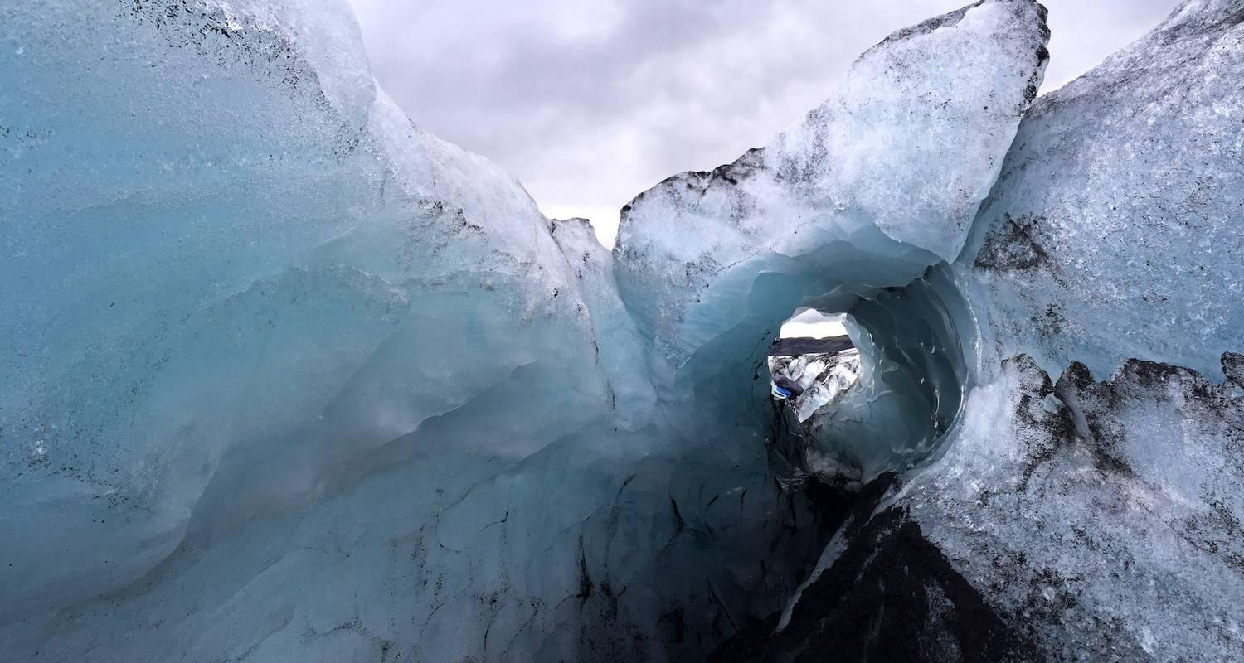

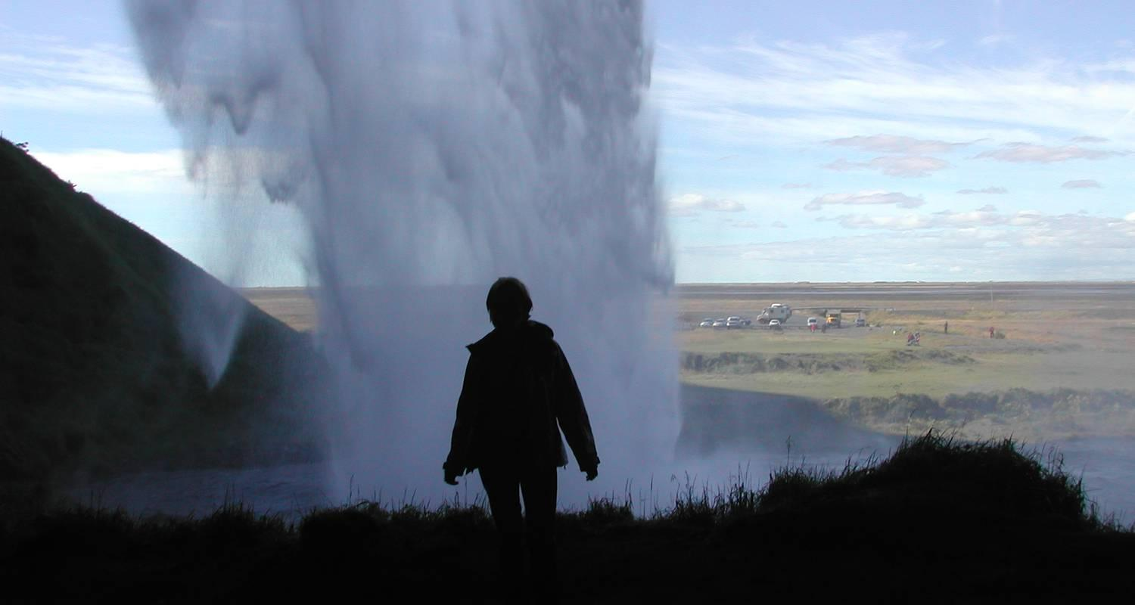

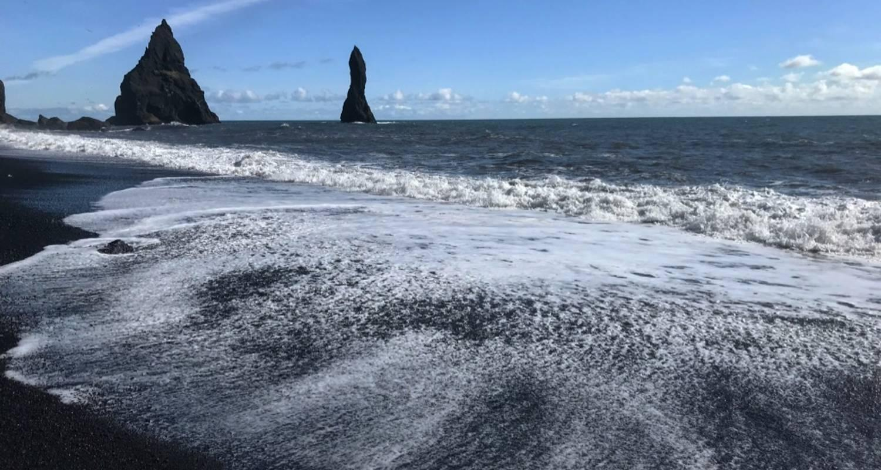

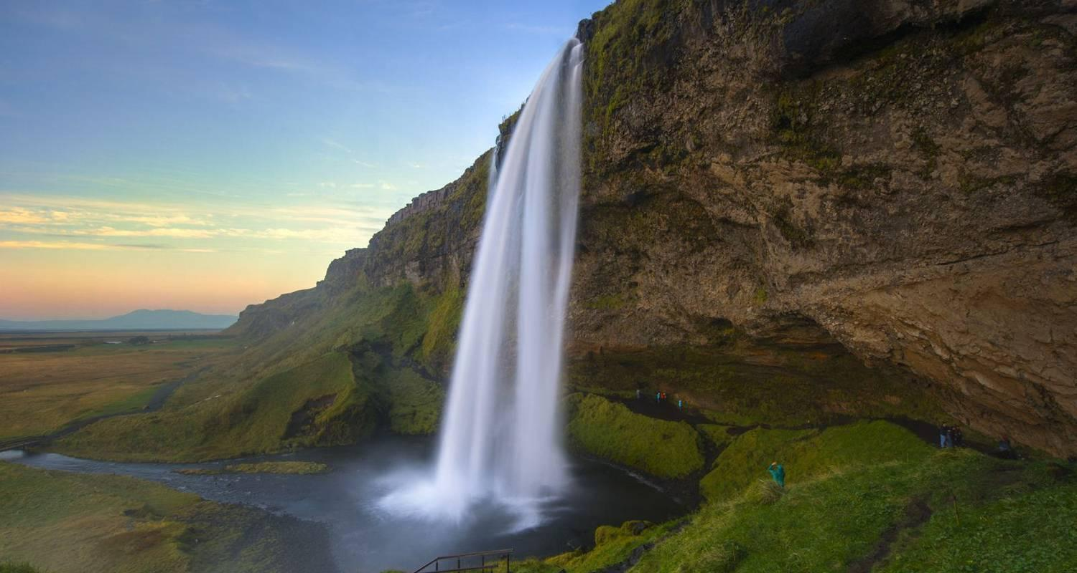

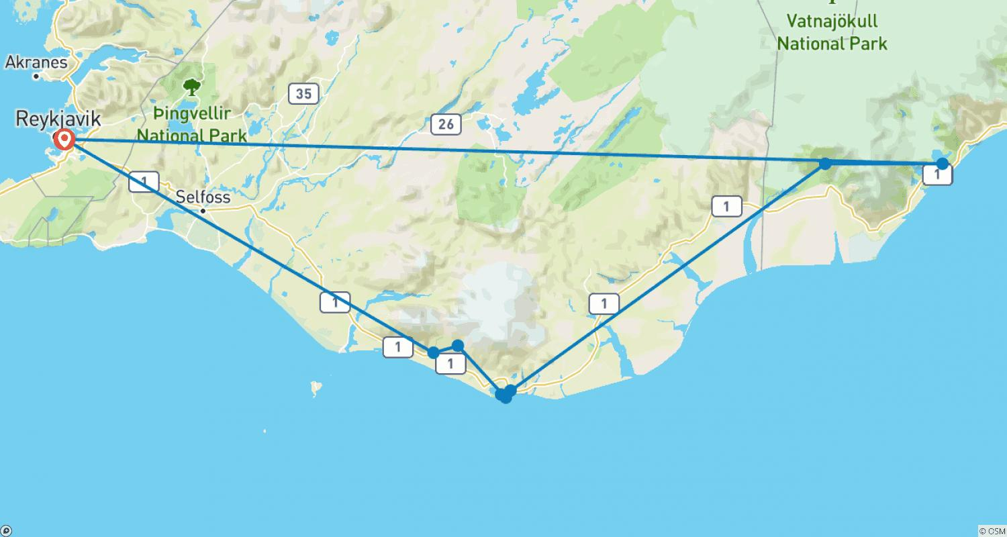

Tour ID: 223632  
Tour Name: 7 Day Family Summer Tour - Private Tour

Tour destinations: ['Reykjavik', 'Blue Lagoon', 'Reykjanesviti', 'Thingvellir National Park', 'Geysir', 'Gullfoss', 'Fludir', 'Secret Lagoon', 'Skogafoss', 'Solheimajokull', 'Reynisfjara', 'Reynisdrangar Cliffs', 'Skaftafell', 'Jokulsarlon', 'Keflavik']

Tour destinations images:

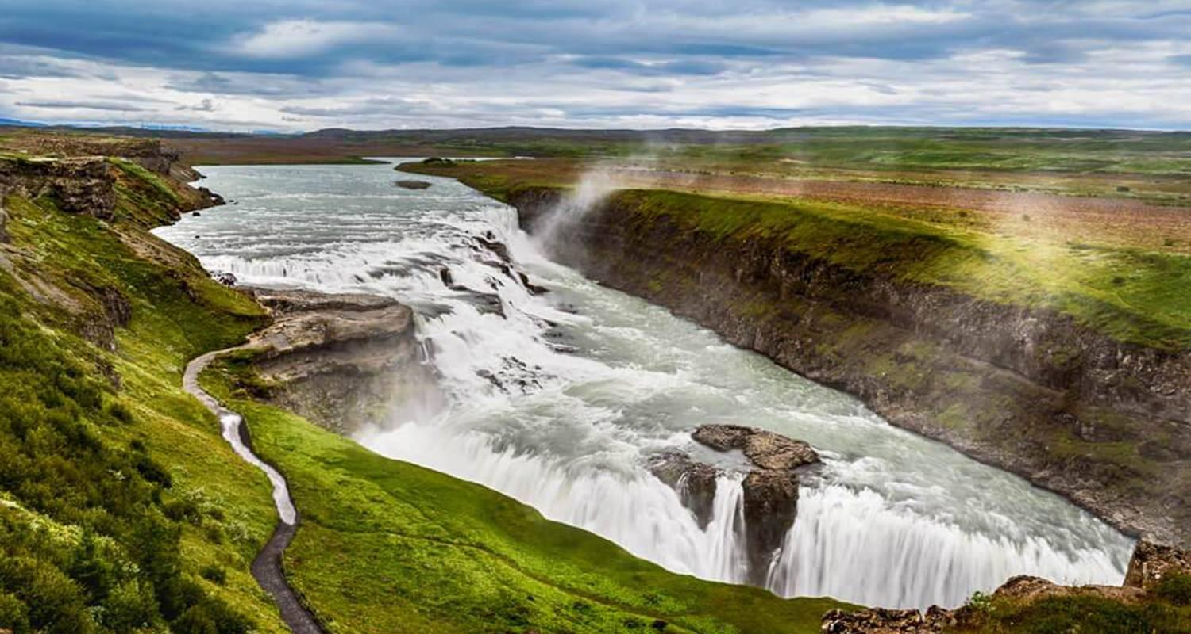

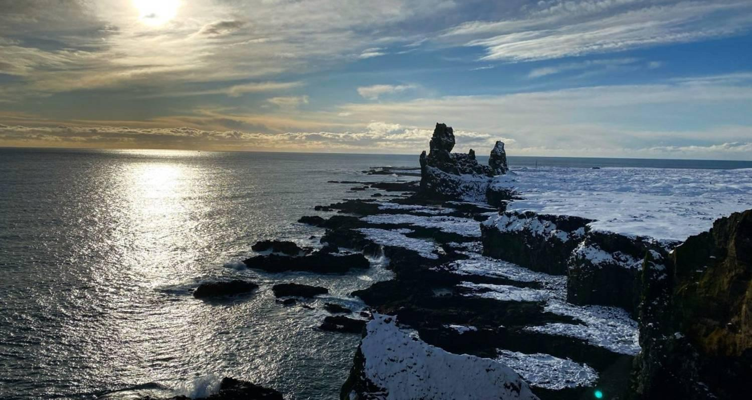

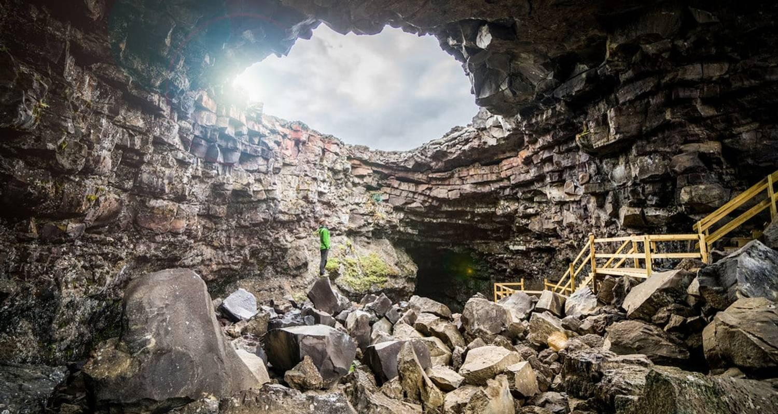

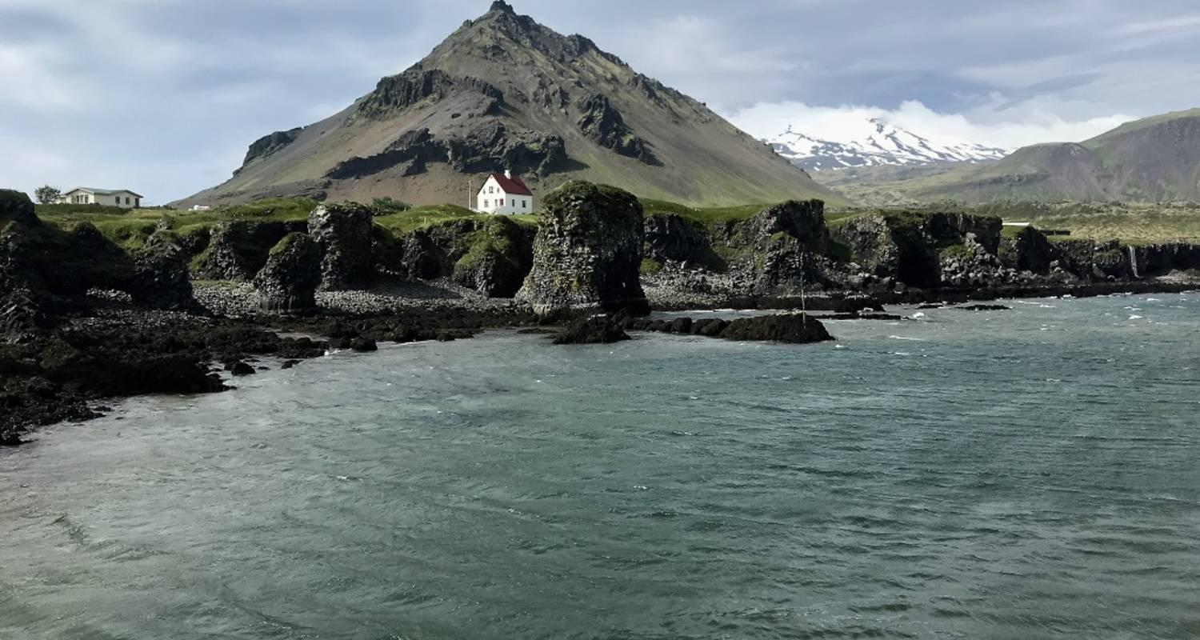

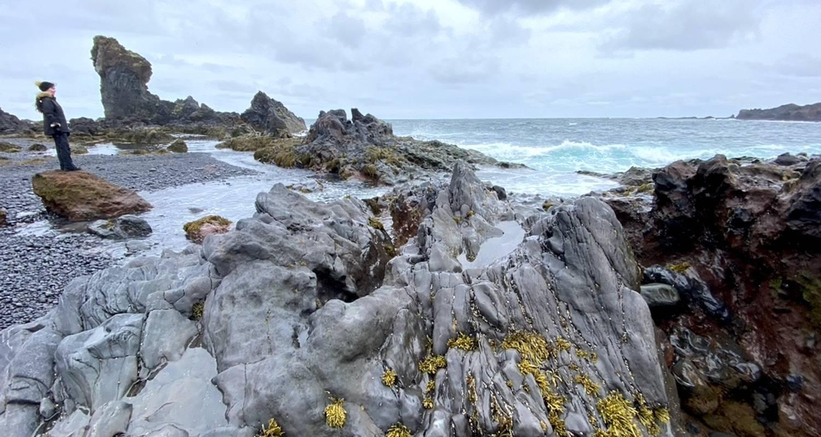



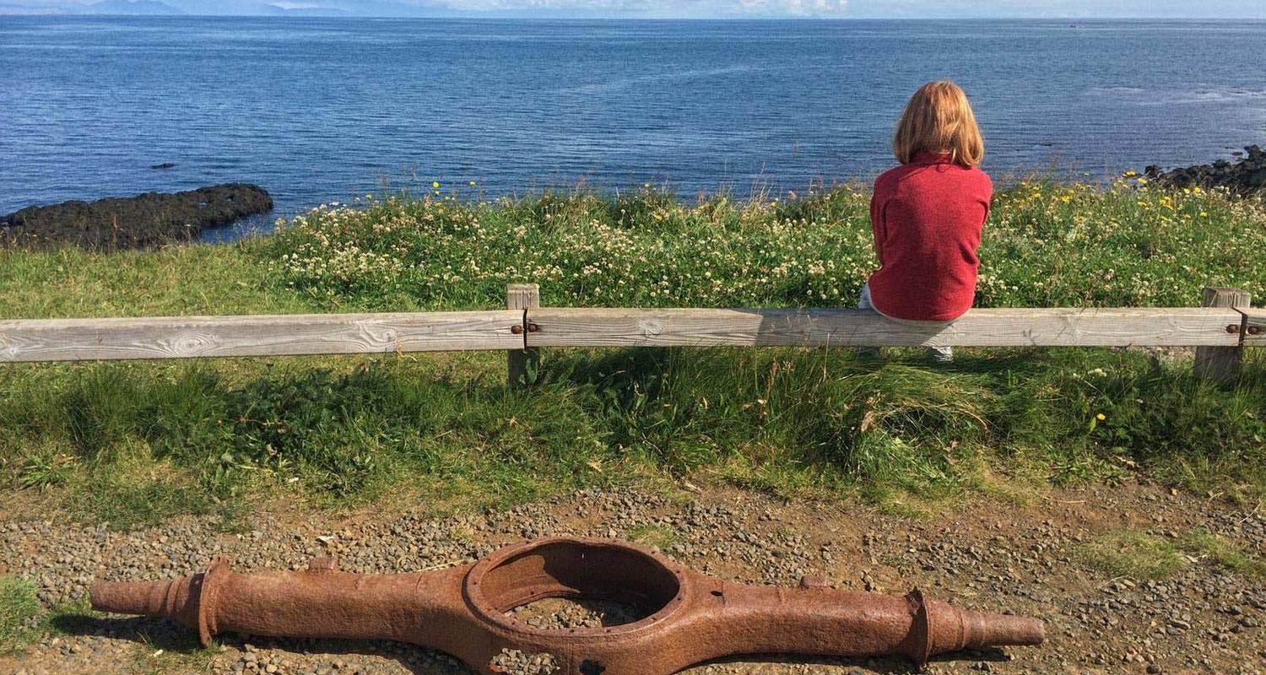

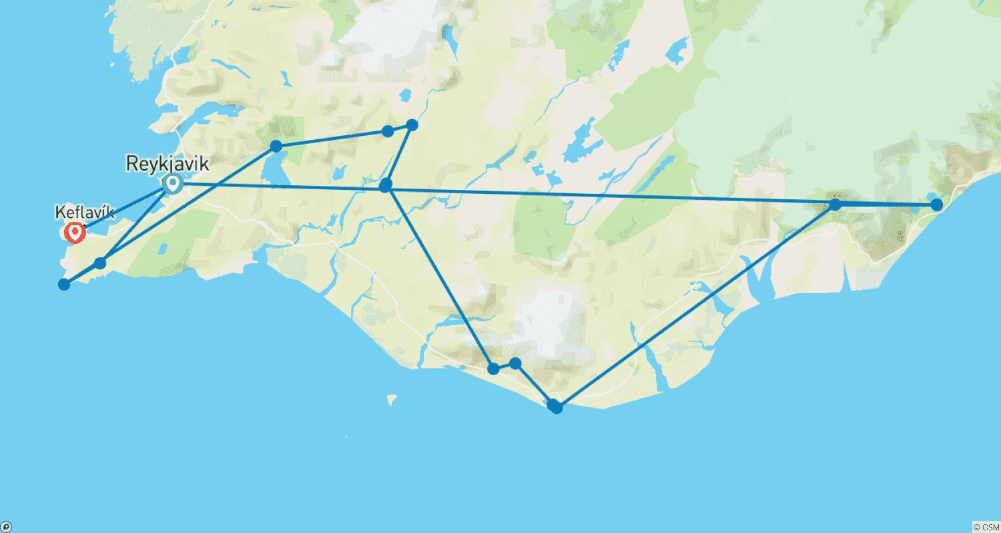

Tour ID: 223819  
Tour Name: 7 Day Family Winter Tour - Private Tour

Tour destinations: ['Reykjavik', 'Blue Lagoon', 'Reykjanesviti', 'Thingvellir National Park', 'Geysir', 'Gullfoss', 'Fludir', 'Secret Lagoon', 'Skogafoss', 'Solheimajokull', 'Reynisfjara', 'Reynisdrangar Cliffs', 'Skaftafell', 'Jokulsarlon', 'Keflavik']

Tour destinations images:



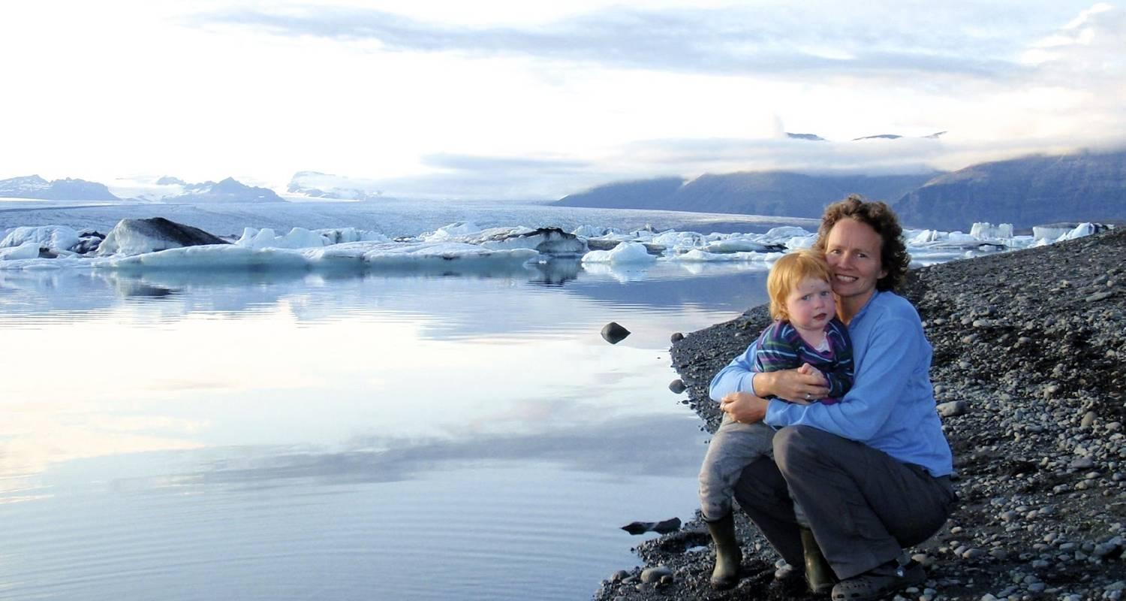

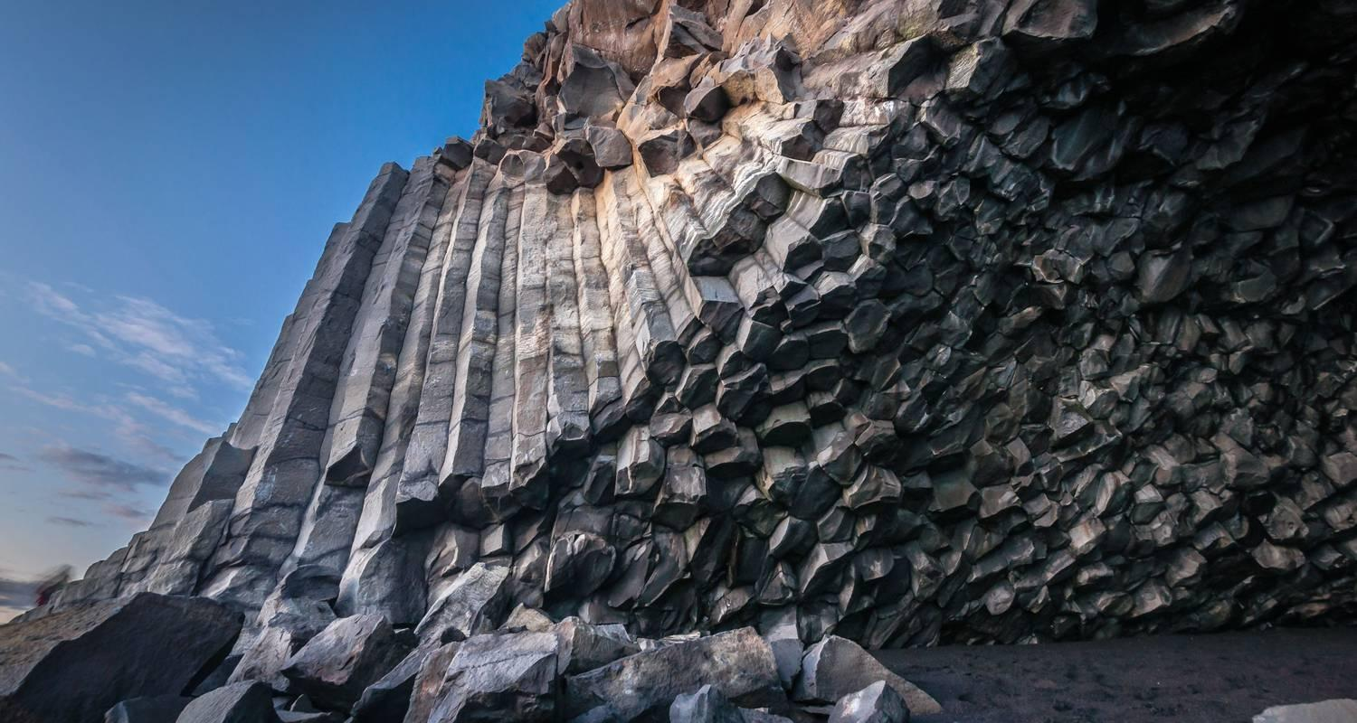









Tour ID: 223902  
Tour Name: 9 Day Around Iceland Family Summer Tour - Private Tour

Tour destinations: ['Keflavik', 'Reykjavik', 'Thingvellir National Park', 'Geysir', 'Gullfoss', 'Skogafoss', 'Reynisfjara', 'Reynisdrangar Cliffs', 'Skaftafell', 'Jokulsarlon', 'Djupivogur', 'Egilsstadir', 'Dettifoss', 'Myvatn', 'Akureyri', 'Kirkjufell Mountain', 'Djupalonssandur', 'Arnarstapi', 'Borgarnes', 'Reykjanesviti', 'Blue Lagoon']

Tour destinations images:

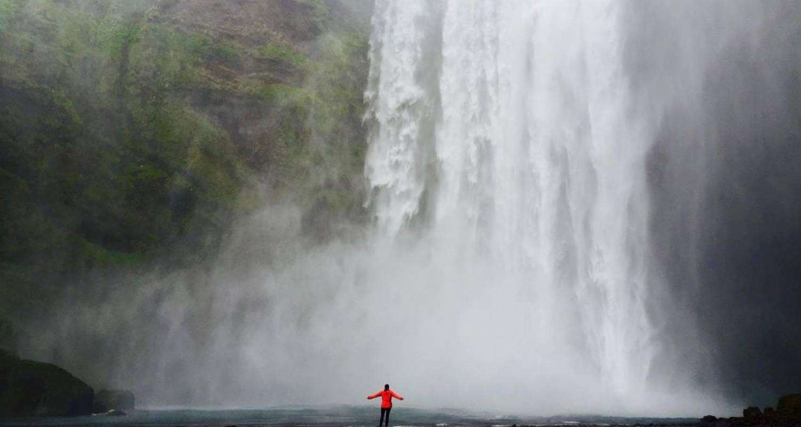

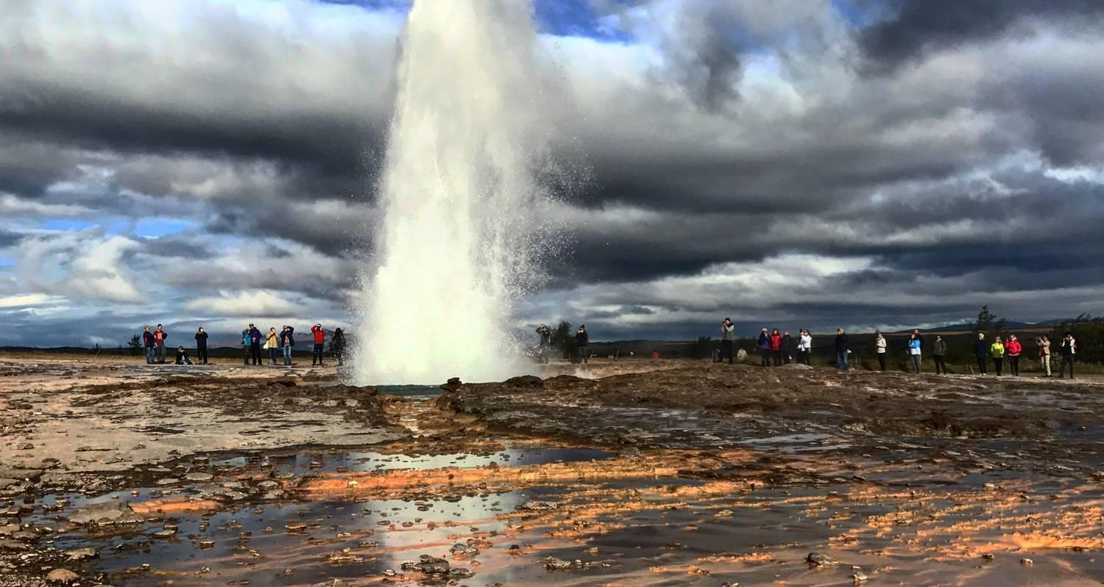



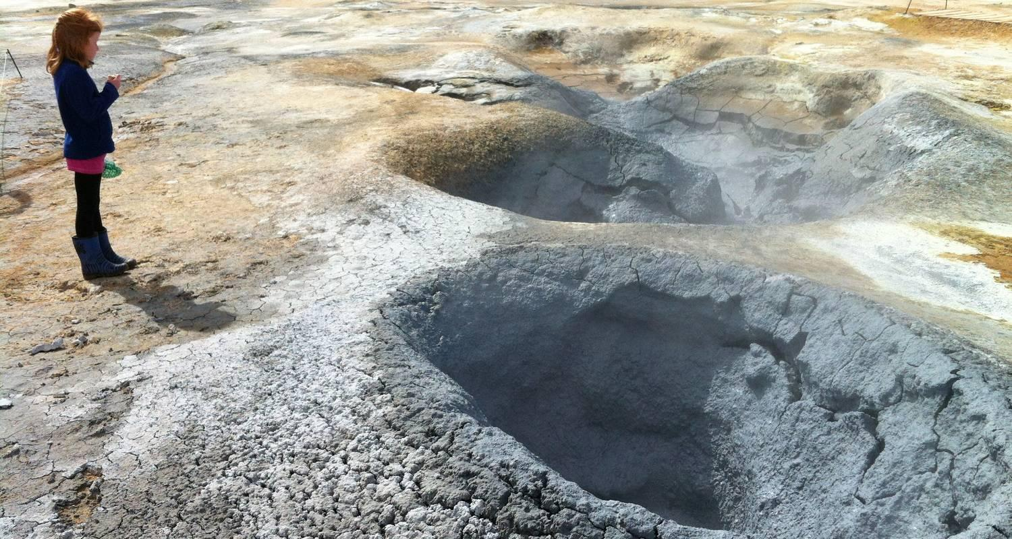

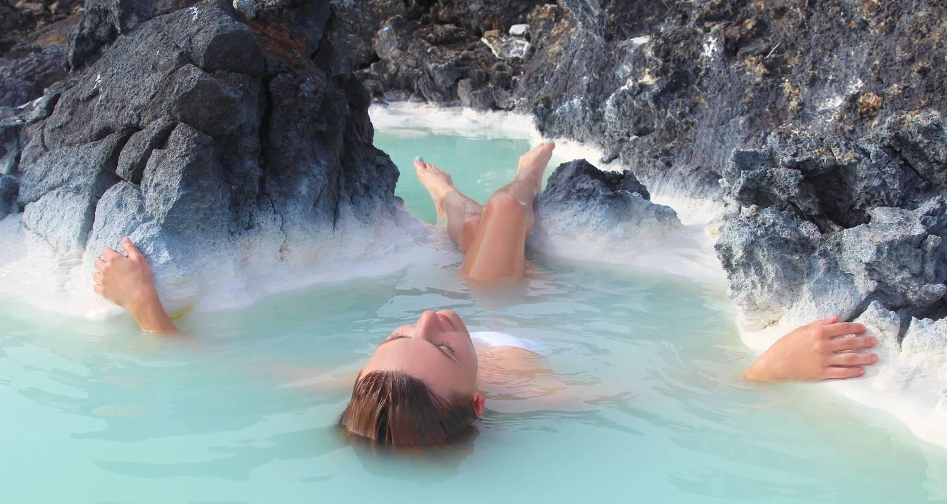

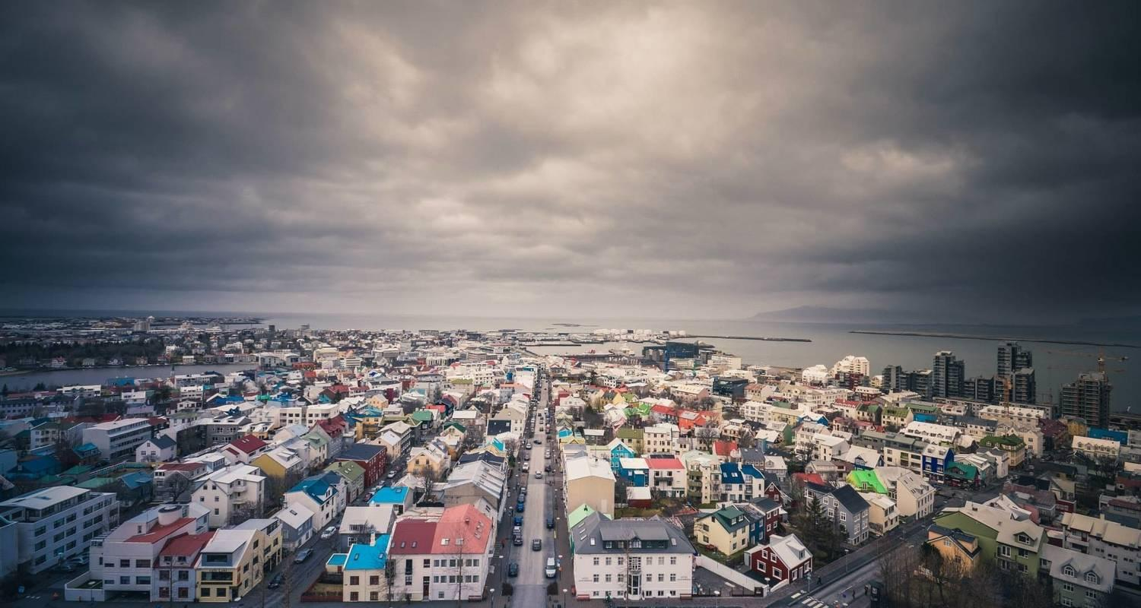

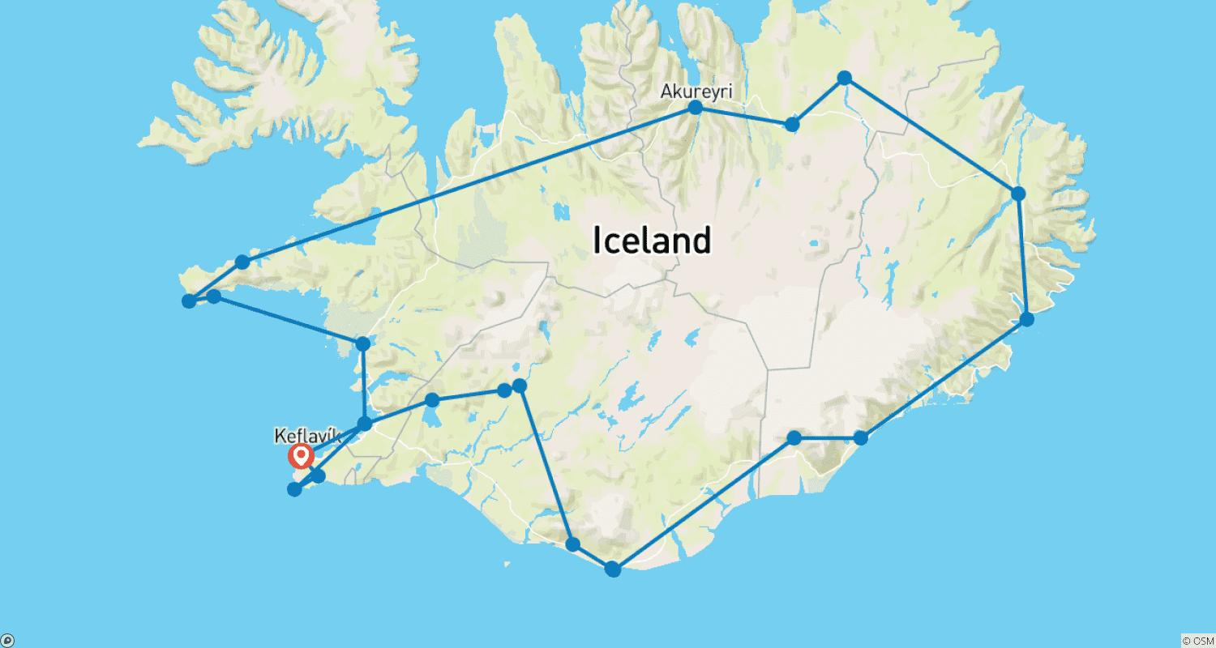

Tour ID: 224079  
Tour Name: 9D8N ICELAND | REYKJAVIK, SOUTH COAST, SNÆFELLSNES & NORTHERN LIGHTS (Group Tour)

Tour destinations: ['Keflavik', 'Blue Lagoon', 'Reykjavik', 'Skogafoss', 'Jokulsarlon', 'Reynisfjara', 'Thingvellir National Park', 'Geysir', 'Gullfoss', 'Reykholt', 'Hraunfossar', 'Borgarnes', 'Arnarstapi', 'Djupalonssandur', 'Kirkjufell Mountain']

Tour destinations images:

